Location, Date

Important information on Accu-Chek® Aviva / Accu-Chek® Performa blood glucose meters potentially having power-related issues
Dear valued customers [please personalize],

At Roche Diabetes Care, we strive for highest quality of our products and services and are committed to keeping you informed as soon as there is a potential issue you should be aware of. This is why we would like to inform you today about a potential issue that might occur in Accu-Chek® Aviva / Accu-Chek® Performa blood glucose meters. As part of our ongoing quality monitoring and market surveillance processes, we have identified that Accu-Chek® Aviva / Accu-Chek® Performa blood glucose meters may potentially have unexpected short battery life or not power on.

Description of Situation

An issue was discovered during the manufacturing process of the meter where an internal component of the meter might have been damaged. In a small percentage of meters, this damage could cause an accelerated depletion of the meter’s battery. Roche Diabetes Care implemented corrective actions to prevent this root cause from recurring in the future.
However, in the worst case, this issue may result in meter unavailability for the user, and failure to test could cause a delay in therapy decisions potentially leading to a serious medical condition. As patient safety is our primary concern, we would like to provide you with the detailed instructions on how to handle the issue if it were to occur.

Details on affected devices

The following products are affected:
Commercial Name
Accu-Chek® Aviva blood glucose meters | serial numbers between XXX05000001 and XXX06335297 OR serial numbers between XXX20000000 and XXX23284925
Accu-Chek® Performa blood glucose meters | serial numbers between XXX20000000 and XXX25525056

Rationale giving rise to this corrective measure
The damage of the internal component of the meter may result in a meter unavailability for the user, and failure to test could cause a delay in therapy decisions potentially leading to a serious medical condition.

Actions taken by Roche Diabetes Care
Roche Diabetes Care implemented corrective actions to eliminate the root cause for the damage of the internal component.

Actions to be taken by the user of the Accu-Chek® Aviva / Accu-Chek® Performa blood glucose meters
In order to troubleshoot any power related issue, refer to the instructions in the user’s manual on how to appropriately handle any errors that may occur. If the instructions provided in the user’s manual are not solving the issue, please contact our Roche Diabetes Care Customer Care line at xxx-xxx-xxx to obtain further support. Additional user information on the handling of Accu-Chek® Aviva / Accu-Chek® Performa blood glucose meters are provided on the Accu-Chek.com webpage.

Please find below the following warning and important notices regarding potential power issues.
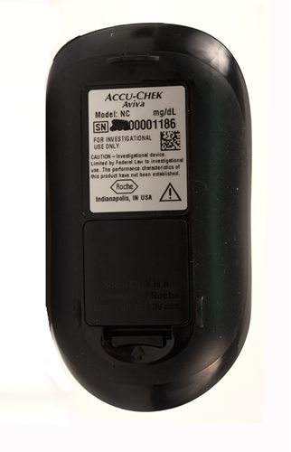
- Notice:
If you use a meter with a serial number (where "XXX" is the first 3 digits of the serial number) in the defined serial number range, you may have a meter potentially impacted by the damaged component.
- Accu-Chek® Aviva: between XXX05000001 andXXX06335297 OR
- Accu-Chek® Aviva: between XXX20000000 and XXX23284925
- Accu-Chek® Performa: between XXX20000000 and XXX25525056

- If you believe you have a meter in the impacted serial number range, please consider the following warnings:
- Always have a spare set of batteries.
- Have a back-up testing method available.

Communications of this Field Safety Notice

Your national competent authority has been notified about this field action.

We sincerely apologise for any inconvenience this may cause and hope for your understanding and your cooperation.

Please call our Roche Diabetes Care Customer Care line at xxx-xxx-xxx, if you need any additional advice on the handling of the Accu-Chek® Aviva / Accu-Chek® Performa blood glucose meters or have any further questions or concerns. We appreciate your time and attention to this important notification.

Kind regards,
Roche Diabetes Care

