---------------------------------------------------------------------------------------------------------------------------

**Field Safety Notice**

**Commercial name of the affected product:** RegenKit-BCT-3T (ref. RK-BCT-3T)

RegenKit-BCT-2A (ref. RK-BCT-3T)

RegenKit-BCT-4 (ref. RK-BCT-3T)

**FSCA-identifier***2019-01-11-A-FSCA*

**Type of action***Product Recall*

**Please note that this action only applies to specific product codes and does not affect all**

**product codes and LOTs RegenKits products.**

---------------------------------------------------------------------------------------------------------------------------

Date:  *06.02.2019*

Attention to: *QA Responsible, Warehouse Manager, Physicians, Hospitals, Clinics and Pharmacists who received the concerned products.*

**This notice should be forwarded to all those who need to be aware of it within your organization and to maintain the awareness over the appropriate defined period.**

**Details on affected devices:**

Are concerned by this recall specific product codes of class IIb devices:

|  |  |  |
| --- | --- | --- |
| **Product Code** | **Lot Number** | **Expiration Date** |
| RK-BCT-3T | 006 | 04.04.2020 |
| RK-BCT-2A | 024 | 04.04.2020 |
| RK-BCT-4 | 019 | 04.04.2020 |

**Description of the problem:**

Regen Lab SA, has voluntarily initiated a recall for specific product codes listed above that may not meet design specification. This action is being performed by Regen Lab SA with the full knowledge of the national regulatory authorities.

During internal non-conformity, it was identified that RegenBCT tubes batch number 18D04, used to manufacture product listed above, may not meet the vacuum specification (10ml). It was evaluated that probably 800 tubes may miss vacuum, part of a batch of 6000 tubes.

The non-conformity concerns the vacuum specification of the product. Sterility and safety of product are not affected. The lack of vacuum in tubes has no impact patient and user safety. RegenBCT tubes are designed to collect blood and prepare PRP that is injected back in patient for different therapeutical indications. If tubes have no vacuum, tube cannot be used and tube must be replaced. Furthermore, the instructions of use mention “Do not use tube if vacuum is lost”

No adverse events related to vacuum problems were reported for these batch until now.

Although safety requirements are fulfilled, this procedure recall is performed only to recall non-conform product released in the market.

***The recall is conducted at end-user level.***

No supplementary actions will be undertaken on treated patient (as safety of the device is guaranteed).

**Product Identification Procedure:**

The only way to identify affected products is by comparing product code to the recalled product list (see table above).

See Annex 1 for example of package labeling that highlights the location of the product code on the device label which is located on the primary packaging. The product code (reference number) is preceded by the word “REF” and the batch number is preceded by word “LOT”.

**Advise on action to be taken by the distributor/user:**

Our traceability shows that you have taken delivery of affected product. Please follow the steps below according to whether you are a distributor or an end-user in order to return the identified product to Regen Lab*:*

|  |  |
| --- | --- |
| **Actions to be taken by the distributor** | **Action to be taken by the end-user** |
| 1. *Please* ***immediately stop distributing*** *and quarantine all affected products.* 2. *Please complete and return the “Recall Response Form for Distributors” (page 4)* ***no later than March 03, 2019*** *to all the following persons*   *Jean-Baptiste Pignier (jpignier@regenlab.com)*  *Genta Plasari (*[*gplasari@regenlab.com*](mailto:gplasari@regenlab.com)*)*   1. *Inform and send the FSN to end-users* ***no later than March 15, 2019****. They must fill and return to you the “Recall Response Form for End-Users” (page 5). You must then return to Regen Lab the end-user FSN form* ***no later than April 15, 2019*** *to all the following persons*   *Jean-Baptiste Pignier (jpignier@regenlab.com)*  *Genta Plasari (*[*gplasari@regenlab.com*](mailto:gplasari@regenlab.com)*)*   1. *All not used products concenrned by this recall must be returned to Regen Lab* ***no later than April 30, 2019*** *to the following address*   *Regen Lab SA, En Budron B2,  1052 Le Mont-sur-Lausanne, Switzerland*   1. *Your Regional contact will advise on suitable replacement stock.* | 1. *Please* ***immediately stop using*** *all affected products.* 2. *Please fill and return to your distributor the “Recall Response Form for End-Users” (page 5)* ***no later than April 10, 2019.*** 3. *Please* ***return*** *all the unused affected products to your distributor* ***no later than April 15, 2019****.* 4. *Returned products will be replaced by  Regen Lab SA.* 5. *Distributor will advise on suitable replacement stock.* |

Thank you for your business and continued support. We sincerely apologize for any disruption this situation may cause your organization.

**If you have any questions about this action please do not hesitate to contact:**

**For Sales and Logistic queries** Mr. Alain Lecompte, +41218640139, [alecompte@regenlab.com](mailto:alecompte@regenlab.com)

**For regulatory queries**

Mrs. Daphné Van Diermen, Resp. Pharm., Technical Director, or

Mrs. Genta Plasari, PhD, QA Responsible

REGEN LAB SA

En Budron B2,

CH-1052 Le Mont-sur-Lausanne,

Switzerland

Tel. +41 21 864 0111

Fax +41 21 864 0110

e-mail : [gplasari@regenlab.com](mailto:gplasari@regenlab.com), [ddiermen@regenlab.com](mailto:ddiermen@regenlab.com)

**The undersign confirms that this notice has been notified to the appropriate Regulatory Agency.**

Signatures

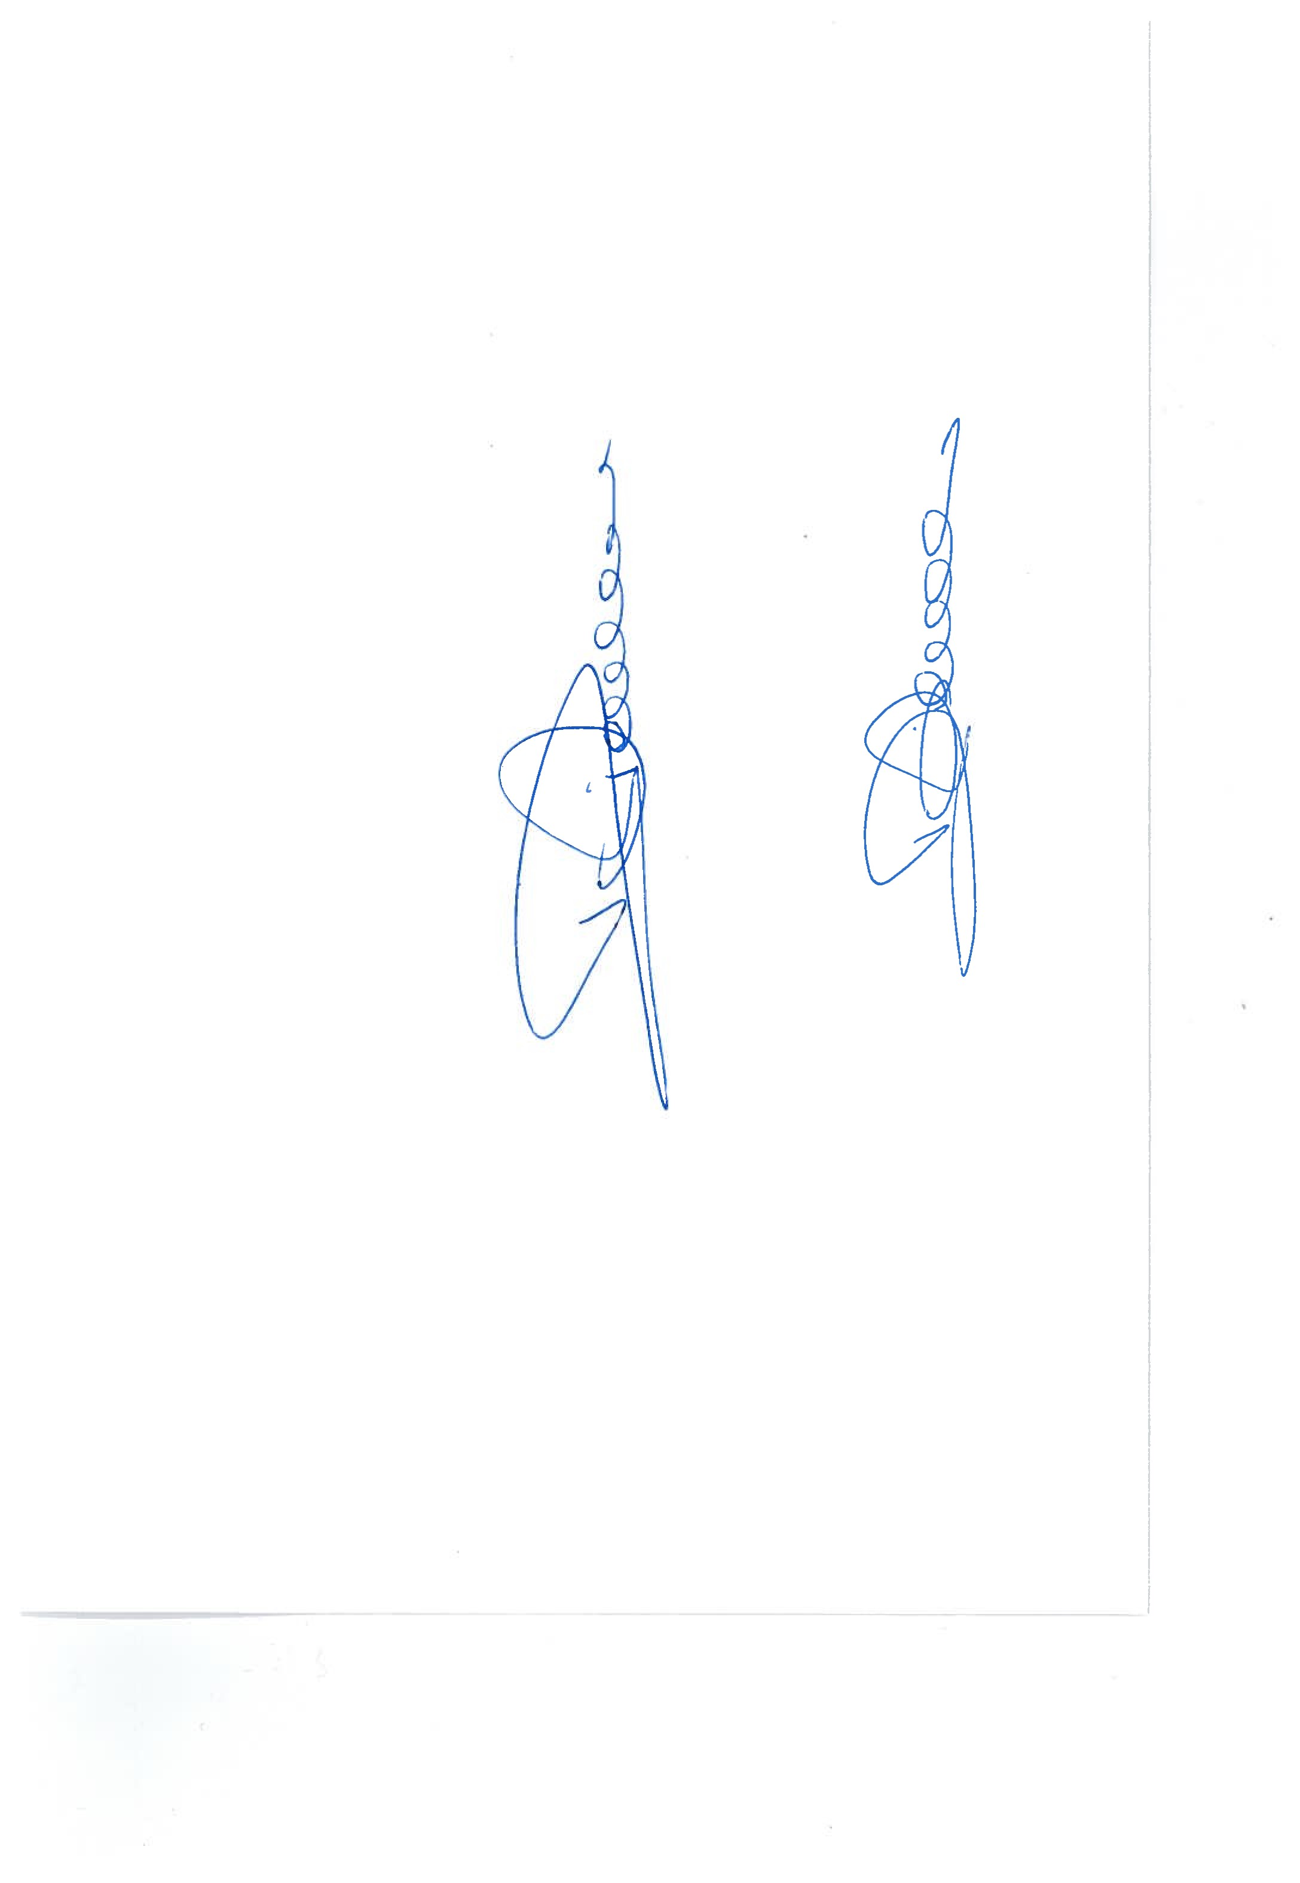

**Daphné Van Diermen** **Genta Plasari**

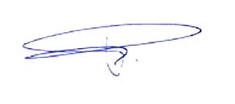Resp. Pharm., Technical Director PhD, QA Responsible

**RECALL RESPONSE FORM for DISTRIBUTORS**

**FIELD SAFETY NOTICE**

**PLEASE COMPLETE AND RETURN by Email**

|  |  |
| --- | --- |
| Distributor Name |  |
| Distributor Address |  |

The following product codes have been distributed to your facility:

|  |  |  |
| --- | --- | --- |
| Product Code  / REF No. | LOT N° | Quantity Delivered  (pieces) |
|  |  |  |
|  |  |  |
|  |  |  |

**Please answer each of the following.**

Have You Distributed the Product Further? 🗆 NO 🗆 YES

*If YES, have you notified down to your customer? 🗆 NO 🗆 YES

*If YES, have you recall the product from your customer? 🗆 NO 🗆 YES

*If NO explain why not:

🗆 We have NO affected products

🗆 We have the Following affected products

**Record quantity (pieces) for each LOT to be returned to Regen Lab:**

|  |  |  |  |
| --- | --- | --- | --- |
| Product Code / REF No. | LOT N° | Units on hand | Units returned |
|  |  |  |  |
|  |  |  |  |
|  |  |  |  |
|  |  |  |  |

🗆 The RECALL RESPONSE FORM for DISTRIBUTORS returned to Regen Lab

🗆 The RECALL RESPONSE FORM for END-USERS returned to Regen Lab

FORM Completed and Returned From:

Name

Date

Signature

**RECALL RESPONSE FORM for END-USERS**

**FIELD SAFETY NOTICE**

**PLEASE COMPLETE AND RETURN by Email to your Distributor**

|  |  |
| --- | --- |
| End-User Name |  |
| Address |  |

The following product codes have been distributed to you:

|  |  |  |
| --- | --- | --- |
| **Product Code** | **Lot Number** | **Expiration Date** |
| RK-BCT-3T | 006 | 04.04.2020 |
| RK-BCT-2A | 024 | 04.04.2020 |
| RK-BCT-4 | 019 | 04.04.2020 |

**Please answer each of the following.**

🗆 We have NO affected products in stock

🗆 We have the Following affected products

**Record quantity (pieces) for each LOT to be returned to Regen Lab via the Distributor:**

|  |  |  |  |
| --- | --- | --- | --- |
| Product Code / REF No. | LOT N° | Units on hand | Units returned |
|  |  |  |  |
|  |  |  |  |
|  |  |  |  |
|  |  |  |  |

🗆 FORM returned to the distributor

FORM Completed and Returned From:

Name

Date

Signature

Annex 1: Examples of Product Labeling

**Labeling printed on Tyvek**

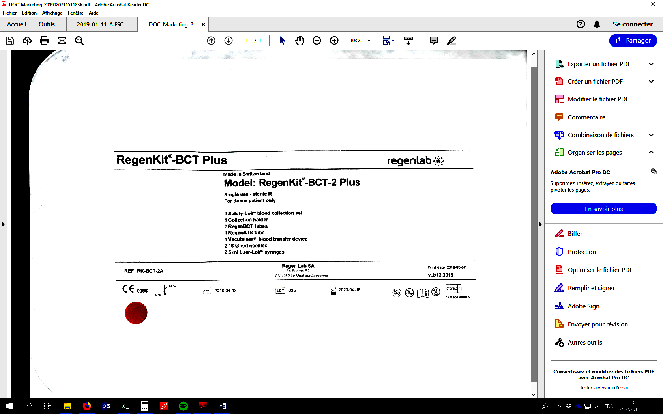

Product code

Batch number

**Label on the folding** **box**



Product code

Batch number