Relevant Country Contact Name
Tel.: Relevant country telephone
Fax: Relevant country fax
Email: Relevant country email

Urgent Recall Notice

Type of Action: RECALL

Devices: The following Intersurgical products containing the Adult EcoliteTM Aerosol Mask.

REF: | DESCRIPTION
1453015 | CIRRUS2 NEBULISER, ADULT, INTERSURGICAL ECOLITE MASK KIT WITH TUBE, 2.1M

LOT NUMBERS
32052973
32053276
32053524

Manufacturer: Intersurgical Ltd

FSCA identifier: 301083 Date: 17/12/2020

Attention: Medical Device Safety Officers (MDSO)

Distribution: All Respiratory Care Units, Hospital Wards and Departments, Emergency Departments, Intensive Care Units, Ambulance/Paramedic staff, Community Nurses, Home Users/Carers, GP Surgeries, Clinics and all users of the above products.

Type of action:
All users of the product and lot numbers listed above must follow the instructions described in the Actions section below before use.

Description of the problem: We have received a complaint where a product that should contain an Adult EcoliteTM Aerosol Mask with vents (Picture 1), has been found to contain a similar mask without vents (Picture 2), this would prevent the patient breathing normally. This could result in distress or some form of harm to the patient if unnoticed. It would also prevent the intended treatment being provided to the patient.

Picture 1: Correct Mask with vents

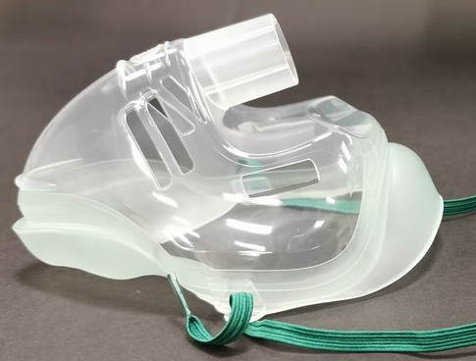

Picture 2: Mask without vents

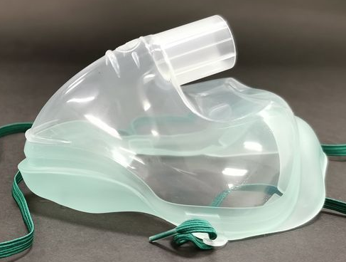

Action to be taken by the user:
Immediately quarantine all affected product codes and lot numbers listed above and do not use these devices. Please contact Intersurgical using the Response Form below to confirm these have been disposed of locally or arrange collection of the devices and credit. If you have no affected devices in your stock, please confirm this also using the Response Form.

Corrective Action being taken by manufacturer Intersurgical:
We have already reviewed the manufacturing process and implemented actions to prevent this error in the future.

The undersigned confirms this notice has been notified to the appropriate Regulatory Agency.

Transmission of this Field Safety Notice:

This notice should be transmitted to all those who need to be aware within your organisation, or to any organisation where these potentially affected devices have been transferred.

Intersurgical apologises for any inconvenience this may cause. If you have any questions, please contact your distributor or local Intersurgical representative.

The relevant National Authorities have been advised about this Field Safety Corrective Action.

Please maintain awareness of this Field Safety Notice and resulting action for an appropriate period to ensure effectiveness of the corrective action.

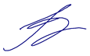

Ivan Seniut, Group Quality and Regulatory Affairs Director, Intersurgical

Relevant Country Contact Name
Tel.: Relevant country telephone
Fax: Relevant country fax
Email: Relevant country email

Urgent Recall Notice Response Form

Devices: The following Intersurgical products containing the Adult EcoliteTM Aerosol Mask.

REF: | DESCRIPTION
1453015 | CIRRUS2 NEBULISER, ADULT, INTERSURGICAL ECOLITE MASK KIT WITH TUBE, 2.1M

LOT NUMBERS
32052973
32053276
32053524

Manufacturer: Intersurgical Ltd

FSCA identifier: 301083 Date: 17/12/2020

Hospital/Facility Name: ________________________________________

Hospital/Facility Address: ________________________________________

________________________________________________________________

Please complete the section below, and send it back to …XXXXXXXXXXXXXXX………………..

We do not have any remaining stock of the affected products.

We have quarantined our remaining stock of the following affected products and wish to return them. Please arrange credit.

I confirm that I have quarantined the following products and lot numbers.
REF | LOT | Quantity of products  per LOT number
1453015
[add more rows as required]

Form Completed and Returned by:

Name: ……………………………………………………………….
Position: ……………………………………………………………
Phone No: ………………………………………………………….
E-mail: ………………………………………………………………
Date: ………………………………………………………………..

