Welch Allyn, Inc.  4341 State Street Road Skaneateles Falls,  NY 13153 USA | URGENT: Field Safety Notice | MOD1329

Date

WA-MOD1329-XXXX
Customer name Customer Street Address Customer Country,

Commercial name of affected product:
WelchAllyn GS777 Wall Transformer (all models) and PRO BP 3400 (handheld, desk mount, wall mount models)

Field Safety Notice

Dear Welch Allyn Customer,

Description of the problem:
Welch Allyn, Inc. (a Hill-Rom Company) is issuing this letter to notify you of the potential risk associated with inadvertent fluid ingress secondary to the cleaning of power supplies used with WelchAllyn GS777 Wall Transformer and ProBP 3400 Blood Pressure Devices. The GS777 Wall Transformer was placed on the market in 2012 and is still being sold. The ProBP 3400 Digital Blood Pressure Device was placed on the market in 2010 and is still being sold.

Potential Risk:
There is a risk of an internal electrical short and possible electrical shock occurring if cleaning fluid ingresses into the power supply, and the power supply is plugged into the electrical outlet before the cleaning fluid has completely dried. This notice is being distributed to make users aware of this potential risk and provide instructions for appropriately cleaning the power supply. The WelchAllyn GS777 is a device that is mounted either on the wall or on a mobile stand. It holds and supplies power to small handheld devices such as ophthalmoscope and otoscope heads. The ProBP 3400 Blood Pressure Device (all models) is a digital blood pressure device that can be used in a handheld, wall-mounted, or mobile configuration.

GS777 Wall Transformer ProBP 3400 Blood Pressure Device
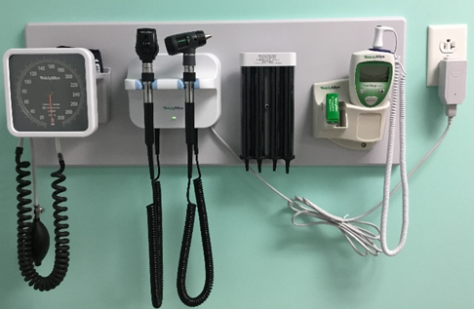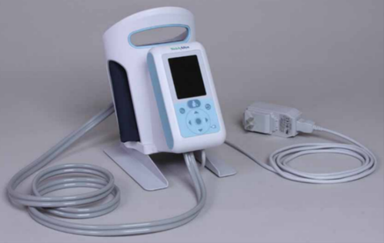

Background:
Hillrom has received 10 complaints regarding electrical shorts in the adapter plug assembly when plugging the power supply used with WelchAllyn GS777 Wall Transformers and ProBP 3400 Mobile Blood Pressure Devices into an electrical outlet. To date, we are aware of one reported injury associated with this issue.
Our investigation has confirmed that the reported complaints were the result of unintentional fluid ingress into the power supply caused during cleaning.
Based on our investigation, unintentional fluid ingress is most likely to occur in the gaps of the adapter plug subassembly pictured below.

Gaps in Adapter Plug Subassembly | Adapter Plug Subassembly Sliding into Power Supply | Gaps when adapter plug subassembly and power supply are fully assembled
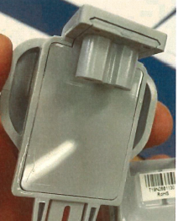 | 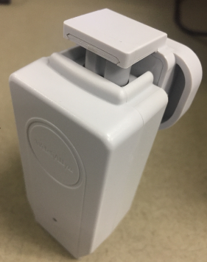 | 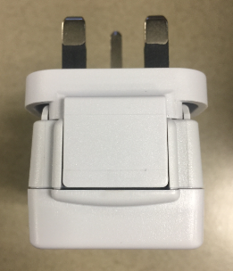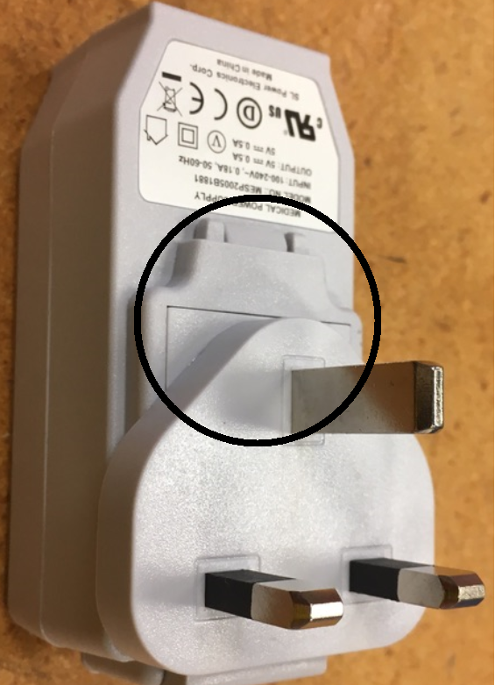
The GS777 and the ProBP 3400 power supplies are not intended to be cleaned with saturated wipes and should not be plugged into an electrical outlet when wet.

To minimize risk of potential electrical shock be sure to follow these cleaning recommendations:

When Cleaning is performed:
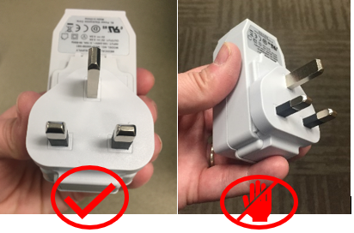

1. Unplug the power supply from the outlet.
2. Ensure the cleaning cloth is not soaking (not dripping or over saturated) with cleaning fluid.
3. Apply minimal pressure on wipe when cleaning; avoid wiping gap areas identified on adapter plug as these areas are most susceptible to liquid ingress.
4. Ensure the power supply and power cord are dry before plugging into electrical outlet.
5. Hold the sides of the power supply when plugging into electrical outlet as pictured below. Avoid contact with bottom of the power supply where cleaning fluid is mostly likely to have accumulated.

Action to be taken by the user:

Please share with potential users in your organization as a reminder to follow the instructions for the proper cleaning techniques. Complete the attached response form and return to hillrom1329OUS@stericycle.com within one month.

Action to be taken by the distributor:

Please share with potential users in your organization as a reminder to follow the instructions for the proper cleaning techniques. Complete the attached response form and return to hillrom1329OUS@stericycle.com within one month. Contact hillrom1329OUS@stericycle.com to receive an electronic copy of this notification and response form and further instructions for notifying your accounts.

Actions being taken by Hillrom:
Hillrom is in the process of updating the GS777 and the ProBP 3400 Instructions for Use (IFU) to include the cleaning recommendations listed above. The IFU for the products may be found at these URLs:

GS777 Wall Transformer:
https://www.hillrom.co.uk/content/dam/hillrom-aem/us/en/sap-documents/LIT/80026/80026575LITPDF.pdf

ProBP 3400:
https://www.hillrom.com/content/dam/hillrom-aem/us/en/sap-documents/LIT/80021/80021999LITPDF.pdf

These links will be updated with the new IFU cleaning instructions once available.

Contact Reference Person:

Should you have any questions regarding this notification, please contact Hillrom/Welch Allyn Technical Support, using email or number below.

Region/Country | Technical Support Phone | Technical Support Email
CZECH REPUBLIC | +353 (0) 46 90 67 790, Option 3 | eme.techsupport@hillrom.com
GERMANY | +49 6950 985 132, Option 3 | eme.techsupport@hillrom.com
ITALY | +39 0269682425, Option 3 | eme.techsupport@hillrom.com
NETHERLANDS | +31 (0) 20 206 13 60, Option 3 | eme.techsupport@hillrom.com
BELGIUM | +31 20 206 13 60, Option 3 | eme.techsupport@hillrom.com
SLOVENIA | +353 (0) 46 90 67 790, Option 3 | eme.techsupport@hillrom.com
RUSSIA | +353 (0) 46 90 67 790, Option 3 | eme.techsupport@hillrom.com
POLAND | +353 (0) 46 90 67 790, Option 3 | eme.techsupport@hillrom.com
FRANCE | +33 1 57 32 49 94, Option 3 | eme.techsupport@hillrom.com
LATVIA | +353 (0) 46 90 67 790, Option 3 | eme.techsupport@hillrom.com
TURKEY | +353 (0) 46 90 67 790, Option 3 | eme.techsupport@hillrom.com
MOROCCO | +353 (0) 46 90 67 790, Option 3 | eme.techsupport@hillrom.com
CROATIA | +353 (0) 46 90 67 790, Option 3 | eme.techsupport@hillrom.com
PORTUGAL | +353 (0) 46 90 67 790, Option 3 | eme.techsupport@hillrom.com
UNITED KINGDOM | +41 44 6545315 | eme.techsupport@hillrom.com
SWITZERLAND | +44 207 365 6780, Option 3 | eme.techsupport@hillrom.com

Transmission of this Field Safety Notice:
Please ensure this notice is circulated to all appropriate personnel. This may include, but is not limited to:

- A&E departments | - In-house maintenance staff
- Adult intensive care units | - IV nurse specialists
- All wards & Clinics | - Medical directors
- Biomedical engineering staff | - Nursing executive directors
- Clinical governance leads | - Oncology units
- Day case theatres | - Pediatric intensive care units
- EBME departments | - Risk managers
- Equipment stores & Libraries | - Supplies managers
- Health and safety managers | - Theatres

The undersign confirms that this notice has been communicated to your local Regulatory Agency.

Sincerely,

Joel Roth
Director, Quality Assurance

Response Form / Receipt
Subject: GS777 Wall Transformer and ProBP 3400 Potential Fluid Ingress (MOD1329)
It is important that you return this form as acknowledgement of your receipt and provide us with the necessary information.
Please complete the following with the correct information and return this Response Form within one month. Thank you!
WelchAllyn/Hillrom account number (if known): _____________________________________

Name of the facility:_________________________________________________
Address of the facility: ______________________________________________
City: Zip: Country:
Facility Contact Person Name: (print) _________________________________________________________________
Signature: Date: ____/____/
Title: Phone:
Email: _____________________________________________________

Check actions taken:
We have reviewed and understand the attached Urgent Medical Device Safety Notice, and have instructed those involved on proper cleaning instructions
☐ Yes ☐ No

We have distributed the product further and notified additional consumers of the attached Urgent Medical Device Safety Notice per the instructions noted above. ☐ Yes ☐ No

Response form shall be returned to hillrom1329OUS@stericycle.com within one month.

