15th January 2019
URGENT: FIELD SAFETY NOTICE – MMS-19-1572

T34 TM and T34LTM (T60TM) Ambulatory Syringe Pumps
Serial numbers: All Serial Numbers
Type of Action: Advisory Notice

Attention: EBME Managers, Clinical Personnel, Risk Managers, End of Life care providers (e.g. hospices)

This letter contains important information which requires your attention.

Dear Customer,

BD/CME is issuing this Field Safety Notice to inform users of the T34™ and T34LTM (T60TM) Ambulatory Syringe Pumps of updates to the Directions for Use (DFU) and the Technical Service Manual (TSM) to include additional instructions for pump set up and maintenance.
Description:
Through Post Market Surveillance feedback, BD/CME has identified that the syringe pump motor block mechanism may be affected overtime by “wear / tear”. This scenario causes under infusion situations without the pump alarm being generated.
The issue can be observed when the actuator does not move when the lead screw is rotating, resulting in potentially no pressure on syringe plunger to deliver the syringe contents. The cause of this issue is the actuator nut being worn enough to stop or lose traction on the lead screw due to irregular coating of the actuator. The “wear / tear” effect can be visually observed as the lead screw is progressively wearing the plastic actuator nut overtime, leaving white plastic debris along the lead screw (see Figure 1 below).

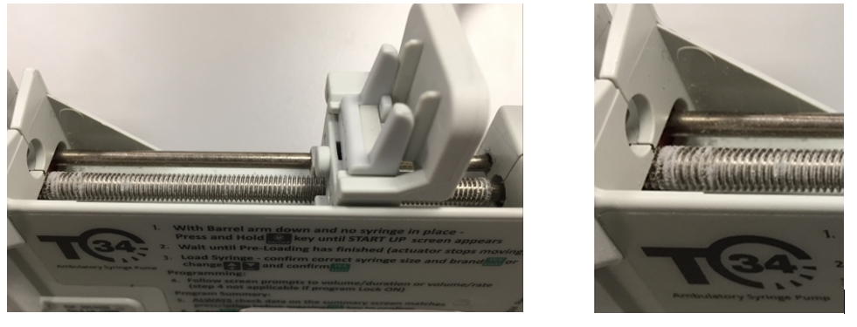
Figure 1: Lead Screw & white plastic debris

- Corrective Actions by BD/CME
BD/CME has revised the Directions for Use (DFU) to include specific instructions for Users to check for plastic white debris on the lead screw during pump set up (Appendix 1). Also, BD/CME has updated the Technical Service Manual (TSM) instructions outlining changes to the maintenance and repair processes to check for plastic white debris on the lead screw and to preventively change the leadscrew and/or motor block assembly where necessary. The pump has to be checked prior each use for plastic white debris. Users responsible for pump set-up need to doublecheck that the infusion rate and amount was as prescribed, due to the fact that the pumps will not alarm the user in case of underinfusion.
This Field Safety Notice is to make you aware of these changes and to provide a copy of these revised instructions to be used with your pumps. The updated service instructions will be made available to the trained service organisations.
- Actions Required of You (T34 TM & T34L TM (T60TM) Pump Users):
- Do not use the pump in case an alternative infusion pump is available

- Double check infusion rate and amount.

- Read and distribute this FSN and ensure that all the contents are understood by those within your organisation who need to be aware

- Ensure users responsible for pump set-up are aware of Appendix 1 (revised set-up instructions)
  - Attach Appendix 1 to the current Directions for use (DFU) for your pumps and ensure its contents are made available to users.

- Return the signed and completed Customer Acknowledgement Form to <<insert contact details here>> no later than the <<insert date>>.
  - Upon receipt of the form, BD will contact your facility regarding the lead screw replacement.

- If you are no longer in possession of the T34™ or T34LTM (T60TM) Ambulatory Syringe Pumps, please pass this Field Safety Notice and all the related documentation to the current user(s).

BD/CME will replace all affected units (actuator/screw) in the pump or the pump itself.

Should you have any questions or require assistance relating to this Field Safety Notice, please contact your local BD/CME representative. We confirm that the appropriate regulatory agencies have been informed of these actions.

BD/CME is committed to ensuring that safe and effective product is available to customers and this Field Safety Notice is taken with due consideration of this commitment.

Thank you for your attention and cooperation.

Yours sincerely,

BD/CME Signatory

Appendix 1 - Addendum to the Directions for Use for the T34™ and T34L™ (T60™) Ambulatory Syringe Pumps
Appendix 1 – Addendum to the Directions for Use for the
T34TM and T34LTM (T60TM) Ambulatory Syringe Pumps
(T34™ Directions for Use document reference number: 100-090SM / 100-090SS
T34L™ (T60™) Directions for Use document reference number: 100-090SL / 100-090SLM)

Monitoring and Managing Infusions

Pump and Infusion Safety Checks
Inspect the lead screw prior to use (See 3.2 Pump Description, item 4). If there is white plastic debris on the lead screw, this is an indication of wear on the syringe mechanism. Therefore, discontinue use and send the pump for service.

_____________________________________________________________________________________
Customer Acknowledgement Form – MMS-19-1572
T34 TM and T34LTM (T60TM) Ambulatory Syringe Pump
Serial numbers: All Serial Numbers

Please read in conjunction with Field Safety Notice MMS-19-1572 and return completed and signed form to as soon as possible or no later than the xxxxxxxx 2019 to

By completing the information below you confirm you have read, understood and distributed the contents of this Field Safety Notice accordingly

Upon receipt of the form, BD will contact your facility regarding the lead screw replacement.

Name of Hospital/facility
Hospital/Facility Address
Type of establishment (please select) | ☐ Hospital ☐ Homecare
Telephone Number |  | Email address
Name
Signature |  |  | Date

Please return your completed and signed Acknowledgement Form to: Please insert email address

