Date: 21/11/2022
Intersurgical Ltd.

Urgent Field Safety Notice
NEONATAL, NASAL CANNULA WITH CURVED PRONGS AND TUBE, 2.1M

For Attention of*: All clinical staff, Managers and users of the above product

Contact details of local representative (name, e-mail, telephone, address etc.)*
Giedrius Budrys
Customer Resolution and Relationship Manager
Intersurgical UAB
Arnioniu str 60, LT-18170 Pabrade Lithuania

Email: giedriusb@intersurgical.lt
Tel. +370 387 66611
Fax: +370 387 66622

or

This could be a distributor or local branch of the manufacturer. To be added at the appropriate stage in the different local languages

Urgent Field Safety Notice (FSN)
Intersurgical Ltd.

NEONATAL, NASAL CANNULA WITH CURVED PRONGS AND TUBE, 2.1M
Risk addressed by FSN

- Information on Affected Devices*
1. | - Device Type(s)*
 | Basic Nasal Oxygen Cannula
1. | - Commercial name(s)
 | NEONATAL, NASAL CANNULA WITH CURVED PRONGS AND TUBE, 2.1M
1. | - Unique Device Identifier(s) (UDI-DI)
 | N/A
1. | - Primary clinical purpose of device(s)*
 | To deliver oxygen into a patient's nose
1. | - Device Model/Catalogue/part number(s)*
 | 1164000
1. | - Software version
 | N/A
1. | - Affected serial or lot number range
 | 32101838 32103910 32104363 32105886 32107401 32107969 32108492 32108661 32113543 32114272 32115031 32115516 32116417 32117131 32118980 32121015 32121426 32122791 32200213 32201328 32203136 32204165 32205503 32205602 32207055 32208628 32209416 32210009 32210465 32210778 32211422 32213464 32214035 32214784 32215283 32215951 32217487 32218056
1. | - Associated devices
 | N/A

- Reason for Field Safety Corrective Action (FSCA)*
2. | - Description of the product problem*
We have received reports related to disconnection of the tube from the nasal prong section while using our Neonatal Nasal Cannula with curved prongs and tube. Image A, below, shows the correct configuration, and image B demonstrates the reported disconnection.

The purpose of this FSN is to advise you that Intersurgical is issuing a voluntary safety notice regarding the use of the Neonatal Nasal Cannula with curved prongs and tube. This safety notice applies to all distributed products with the Lot Numbers indicated above

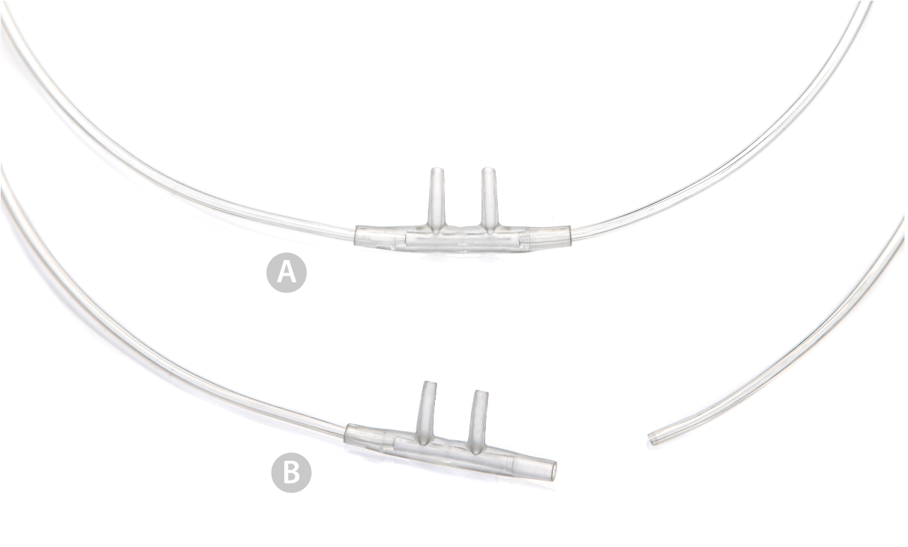

2 | - Hazard giving rise to the FSCA*
 | If the oxygen tubing, which is connected to the nasal prong part of the device, becomes detached (see image B above), oxygen will not be delivered to the patient. There is a risk of oxygen desaturation/hypoxaemia, which could cause life-threatening incidents. Compliance with the instructions for use, provided with the device, will minimise the risks arising from the reported issue and help to identify any affected products.
2. | - Probability of problem arising
 | 1:1,000,000 - 1:10,000
2. | - Predicted risk to patient/users
 | There is a potential for a major effect on the patient health, however it has been assessed as unlikely/rare to occur.
2. | - Further information to help characterise the problem
 | See section 2.3 above
2. | - Background on Issue
 | We have received reports from two hospitals of disconnection of the tube from the nasal prongs whilst in use on patients. We believe this is due to a manufacturing fault, and we are continuing to investigate the problem to identify the root cause.
2. | - Other information relevant to FSCA
 | N/A

 | - Type of Action to mitigate the risk*
3. | - Action To Be Taken by the User*  ☒ Identify Device ☐ Quarantine Device ☐ Return Device ☐ Destroy Device  ☐ On-site device modification/inspection  ☐ Follow patient management recommendations  ☒ Take note of amendment/reinforcement of Instructions For Use (IFU)  ☐ Other ☐ None  Identify any potentially affected devices as indicated in this Field Safety Notice.  You must carefully review and adhere to the Instructions for Use (IFU) provided with the product and as attached for reference. We have provided important excerpts from the IFU to help minimise the specific risk of disconnection in use for the affected products, please see below.  PRE USE CHECK  Ensure all components are undamaged and attached securely.  IN USE CHECKS  Patient monitoring (SaO2) must be used with this device.  Ensure that nasal prongs remain inserted into the nares.  Caution:  1. For use by appropriately trained personnel only.  2. Ensure that trained personnel are familiar with the contents of this instruction.  3. Always perform pre-use checks.  Warning:  1. Patient monitoring (SaO2) must be used with this device.  2. Any use of the medical device requires full understanding and observation of the instructions for use.  3. The medical device may only be used for the purpose specified as the intended use. The clinician should be aware of and consider any known pre-existing medical condition that would preclude or could affect the safe use of the product.  4. Observe all caution and warning statements in these instructions and all information on medical device labels. Non-compliance with these statements is considered to be non-compliant with the intended use of this medical device.  Complete the enclosed Customer Reply Form and return it to the contact at the top of the Response Form. Please continue to report to Intersurgical any adverse events involving this product.
3. | - By when should the action be completed? | Immediately on receipt of this FSN and ongoing until no affected stock listed in this FSN is remaining.
3. | - Particular considerations for: Choose an item.  Is follow-up of patients or review of patients’ previous results recommended?  No  Not applicable
3. | - Is customer Reply Required? *  (If yes, form attached specifying deadline for return) |  | Yes
3. | - Action Being Taken by the Manufacturer  ☐ Product Removal ☐ On-site device modification/inspection  ☐ Software upgrade ☐ IFU or labelling change  ☒ Other ☐ None  Users are advised to follow the Instructions For Use provided with the product.
3 | - By when should the action be completed? | One month of receipt of the FSN
3. | - Is the FSN required to be communicated to the patient /lay user? |  | Yes
3 | - If yes, has manufacturer provided additional information suitable for the patient/lay user in a patient/lay or non-professional user information letter/sheet?
 | No

 | - General Information*
4. | - FSN Type* | New
4. | - For updated FSN, reference number and date of previous FSN | N/A
4. | - For Updated FSN, key new information as follows:
 | N/A
4. | - Further advice or information already expected in follow-up FSN? * | No
4 | - If follow-up FSN expected, what is the further advice expected to relate to:
 | N/A
4 | - Anticipated timescale for follow-up FSN | N/A
4. | - Manufacturer information  (For contact details of local representative refer to page 1 of this FSN)
 | - Company Name | Intersurgical Ltd.
 | - Address | Crane House, Molly Millars Lane, Wokingham, Berkshire, RG41 2RZ
 | - Website address | https://www.intersurgical.com/
4. | - The Competent (Regulatory) Authority of your country has been informed about this communication to customers. *
4. | - List of attachments/appendices: | Customer Reply Form
4. | - Name/Signature | Ivan Seniut, Group Quality and Regulatory Affairs Director, Intersurgical
 | Transmission of this Field Safety Notice
This notice needs to be passed on to all those who need to be aware within your organisation or to any organisation where the potentially affected devices have been transferred. (As appropriate)

Please transfer this notice to other organisations on which this action has an impact. (As appropriate)

Please maintain awareness on this notice and resulting action for an appropriate period to ensure effectiveness of the corrective action.

Please report all device-related incidents to the manufacturer, distributor or local representative, and the national Competent Authority if appropriate, as this provides important feedback..*

Note: Fields indicated by * are considered necessary for all FSNs. Others are optional.

