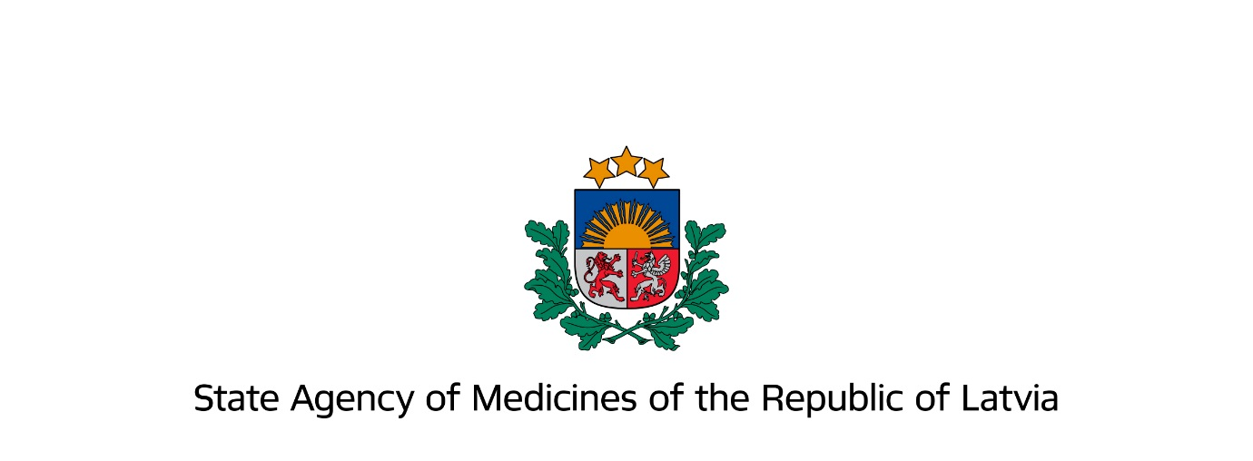

Information for marketing authorisation holders
1 March 2019

Submission and agreement of Direct Healthcare Professional Communications with the State Agency of Medicines

Information regarding Direct Healthcare Professional Communication (DHPC) in situations described in detail in Module XV “Safety communication” of the Good pharmacovigilance practices.

- Normative documents

  - 22 January 2013 Cabinet of Ministers Regulation No. 47 “Procedure for Pharmacovigilance”
  - Good pharmacovigilance practices guidelines

- Situations when distribution of DHPC should be considered

In accordance with module XV “Safety communication” of the Good pharmacovigilance practices DHPC should be distributed in the following situations relating to safety of medicinal products where urgent action is necessary or changes in the current procedure for use of medicinal products should be introduced:

  - Suspension, revocation or withdrawal of marketing authorisation of a medicinal product due to safety considerations;
  - Introduction of significant changes in the use of a medicinal product due to safety considerations by narrowing indications, introducing a new contraindication or amending the recommended dosage;
  - Restriction or interruption of availability of a medicinal product related to its harmful effects on patient health.
  - Other situations when the necessity for distribution of DHPC should be considered:
    - New significant warnings or precautions for use have been introduced in the summary of product characteristics and the package leaflet;
    - New, previously unknown risks or changes in the frequency or severity of known risks have been detected;
    - Substantiated data has been obtained showing that a medicinal product is not as effective as previously believed;
    - New recommendations for prevention or treatment of an adverse reaction;
    - New recommendations to avoid misuse or medication errors with medicinal products;
    - An ongoing assessment of significant potential risks where information available at the moment is insufficient for taking regulatory measures. In this case the following information should be included in the DHPC: encouragement for close monitoring of the potential risk, which has raised the concerns with the medicinal product in clinical practice; encouragement for reporting adverse reactions related to this potential risk; indication how to minimise this risk, if possible;
    - The competent authority may distribute or request the marketing authorisation holder (MAH) to distribute a DHPC in any situation where it considers it to be necessary in order to ensure safe and effective use of medicinal products.

- Address for agreement of the DHPC with the State Agency of Medicines (SAM)

  - DHPC related to situations described in the section “Situations when distribution of DHPC should be considered” should be sent to the e-mail address em_dhpc@zva.gov.lv.
  - Please note that DHPC relating to the quality of medicinal products, counterfeit medicinal products, availability limitations or supply interruption of medicinal products with a potentially harmful impact on patient healthcare and to other issues should be sent to info@zva.gov.lv, phone number for queries: +371 67078424.

- Recommendations for preparing a draft DHPC letter for submission

The DHPC should comply with the requirements defined by normative acts and described in detail in guidelines (see section “Normative documents”). It is recommended that the sample form (Addendum No. 2) is used, when preparing a DHPC.

4.1. The MAH should comply with the following text quality requirements upon preparing a DHPC letter:
- Clear, precise and unambiguous;
- Easy to perceive;
- Laconic;
- Compliant with literary norms of the Latvian language;
- Adequate and consistent use of terminology.
(Compliance with the aforementioned requirements will accelerate the agreement procedure)

4.2. When preparing the letter an additional heading in Latvian “Vēstule veselības aprūpes speciālistam” (“Direct Healthcare Professional Communication”) should be added above its title.

4.3. The name of the active substance and the original name of the medicinal product should be indicated in the topical heading of the letter, if necessary (e.g., for combination medicinal products, vaccines and other biological medicinal products).

4.4. At the beginning of the DHPC letter it must be indicated that it has been agreed by the State Agency of Medicines.

4.5. If a DHPC letter is to be distributed regarding several nationally authorised medicinal products in Latvia and/or centrally authorised medicinal products in the European Union, the MAHs of these medicinal products are recommended to prepare a single common DHPC draft, as well as to mutually agree on the target audience and communication plan. The MAHs should agree which one of them will coordinate the process of DHPC preparation and agreement. When submitting the collectively prepared DHPC draft, target audience and communication plan, the cover letter should indicate that these documents have been prepared in collaboration with other MAHs of specific medicinal products distributed in Latvia. A statement must be included at the beginning of the letter indicating that information included in the DHPC applies to all medicinal products authorised in Latvia containing the specific active substance or substances (if the DHPC is related to the group effect of medicinal products). Annex to the letter must include a list of concerned medicinal products and MAH contact information. The DHPC agreed by SAM should be signed by the letter coordinator on behalf of all of the concerned MAHs.

4.6. The following standard text in Latvian should be included in the “Call for reporting” section of all DHPC letters:
“Atgādinām, ka saskaņā ar zāļu blakusparādību ziņošanas noteikumiem Latvijā ārstniecības personām un farmaceitiem jāziņo par novērotām iespējamām zāļu blaknēm Zāļu valsts aģentūrai (ZVA) elektroniski ZVA mājaslapā www.zva.gov.lv, klikšķinot uz izvēlnes “Ziņot par zāļu blaknēm” un izvēloties “Ārstniecības personas, farmaceita ziņojuma veidlapa”. Papildinformācijas nepieciešamības gadījumā jāsazinās ar ZVA pa tālr.: 67078438”.
(“We remind you that in accordance with the regulations regarding reporting of adverse drug reactions in Latvia healthcare professionals and pharmacists should report observed suspected adverse reactions to the State Agency of Medicines electronically via SAM website www.zva.gov.lv, by selecting “Report Adverse Drug Reactions” and “Healthcare professional/pharmacist report e-form”. For additional information please contact SAM via phone by calling 67078442.”).

If the relevant medicinal product is a biological medicinal product, the text should be supplemented with: “Šīs zāles ir bioloģiskas izcelsmes, tāpēc, ziņojot par blaknēm, jānorāda zāļu oriģinālnosaukums un sērijas numurs” (“This medicinal product is a biological medicinal product, therefore, the original name and serial number of the medicinal product should be indicated when reporting adverse reactions.”)

4.7. In the section “MAH contact information” the following information must be indicated – MAH contact person and their contact information (phone number and address).

4.8. If the DHPC concerns medicinal products that are not distributed in Latvia, SAM should be contacted regarding the procedure for agreement. It should be noted that as soon as a medicinal product enters circulation in Latvia (also when prescribed only to separate patients), it is the responsibility of the MAH to ensure the provision of updated safety information to the relevant target audience.

4.9. The distribution of DHPC to healthcare professionals must not be related to activities promoting the prescription, use or marketing of medicinal products.

4.10. The contact information of healthcare professionals that MAH has obtained within the DHPC communication plan must not be used for purposes of advertising medicinal products.

- Process of submission and approval of the DHPC

  - Submission of DHPC draft (project) to SAM
Should be submitted only electronically by sending to em_dhpc@zva.gov.lv
  - The following documents should be submitted:
    - DHPC draft in Latvian
    - DHPC in English
    - DHPC draft agreement and distribution plan within the EU, if applicable
    - An updated summary of product characteristics and package leaflet in Latvian and in English with highlighted amendments, if applicable
    - List of target audiences to be approved:
- Information for SAM – list of persons, indicating speciality and workplace, if planning on sending the DHPC personally
- For publication on SAM website:
  - List of professional associations
  - If the letter will be sent to doctors personally, indicate: “speciality” – personally
  - List of medical and pharmaceutical establishments and institutions
  - Cover letter indicating:
- Justification for distribution of DHPC
- Target audience and distribution plan (type, date) of the DHPC in Latvia
  - Other supporting or supplementary documents, if necessary.

- Approval process

After submission of DHPC and related documents to SAM the approval process continues via e-mail correspondence with a SAM expert. The SAM expert and submitter should agree upon:
- the plan for approval and distribution of the letter (type, date), basing on the degree of urgency of the specific medicinal product safety issue or the agreement within the EU;
- the DHPC text in Latvian by exchanging commentaries and amendments;
- the list of target audience.

During the agreement process SAM may request the MAH to consult with terminologists, linguists, medical and pharmaceutical professional associations, as well as separate specialists in order to clarify and verify:
- the conformity of terminology;
- the clarity and perceptibility of the information;
- whether the information corresponds with the medical and laboratorial possibilities available in Latvia.

- Confirmation of DHPC agreement by the SAM

When the SAM expert and the MAH have agreed on the final version of the letter, list of target audience and distribution plan, SAM shall send a confirmation of the approval of the letter to the MAH via e-mail: “The letter has been approved by SAM” and shall ask the MAH to submit the agreed DHPC document package (see section No. 8).

- Submission of SAM agreed DHPC document package to SAM

The MAH shall submit the approved document package to SAM, preferably in an electronic (pdf) format by sending it to the e-mail address em_dhpc@zva.gov.lv (the cover letter must be signed with a secure electronic signature or in paper format).

The following documents should be submitted to SAM:

8.1. Cover letter, including the following:
- Information. that the MAH is submitting to SAM the paper format/electronic DHPC approved by a SAM expert via e-mail correspondence (if DHPC is being distributed for several medicinal products clause 4.5 must also be followed)
- The approved target audience
- The approved mode and date of distribution
- Information regarding the reimbursement status (if applicable)
- List of attached documents
8.2. DHPC document version ready for distribution and publication on website, including the following:
8.2.1. The planned date for initiation of distribution of the letter
8.2.2. Signature (if the letter is prepared collectively by several MAHs, the final version should be signed by the coordinator)
8.3. List of target audience to be published on SAM website

- DHPC inclusion in the public Medicinal Product Register of Latvia on SAM website

The approved DHPC version shall be added to the appropriate medicinal product in the Medicinal Product Register of Latvia published on SAM website.

For queries please contact senior experts of the Pharmacovigilance Division of SAM Medicines Marketing Authorisation Department. Phone: +371 67078442, e-mail: Inese.Studere@zva.gov.lv; Gunta.Pauksena@zva.gov.lv.

