B|BRAUN |  | B. Braun Melsungen AG  Division Hospital Care  Marketing & Sales  34209 Melsungen  Germany
 |  | Contact:
 |  | Fon:
TO WHOM IT MAY CONCERN |  | Fax:
 |  | Email:
 |  | Internet:
 |  | Date: | September 11, 2018

Urgent Field Safety Notice

220-240V Unit Cable (power cord) for Infusomat fmS, Infusomat P and SpaceCover

Dear valued customer,

The safety of patients and users as well as the reliability of our infusion pumps are top priorities for B. Braun. It has been observed that a standard power cord which we provided with some of our infusion pumps might get damaged at the device connector Type C13 (according to IEC 60230) if heavy lateral force is applied as a result of improper handling.

Although the supplier of the power cord will not initiate a mandatory recall, we, B. Braun Melsungen AG, have decided to offer the free replacement of affected power cords in the context of a voluntary FIELD SAFETY CORRECTIVE ACTION .

Affected power cords have been manufactured by our supplier HAWA in the period from July 2016 (marked as M7 Y6) until June 2018 (marked as M6 Y8). Therefore power cords with the following marks at the mains plug might be affected (see figure 2).

Year | 8 | 8 | 8 | 7 | 7 | 7 | 7 | 7 | 7 | 7 | 7 | 7 | 6 | 6 | 6 | 6 | 6
Month | 6 | 3 | 2 | 12 | 11 | 10 | 9 | 8 | 6 | 5 | 3 | 2 | 12 | 11 | 10 | 8 | 7

The affected power cord has been shipped together with one of the following products: Infusomat P Deutsch 230 V (8712174), Infusomat P Netherlands 230 V (8712190), Infusomat P Czech 230 V (8712344), Infusomat P English 230 V (8712379), SpaceCover Comfort (8713145), SpaceCover Standard (8713147), Infusomat fmS Deutsch 230 V (8715424), Infusomat fmS Danish 230 V (8715432), Infusomat fmS Spanish 230 V (8715459), Infusomat fmS French 230 V (8715521), Infusomat fmS English 230 V (8715548), Infusomat fmS Italian 230 V (8715564), Infusomat fmS Czech 230 V (8715580) and as separate 220-240V Unit Cable (34502718).

Reason for the FSCA
In the course of Post Market Surveillance Activities we discovered that the above specified power cords might get damaged at the device connector. In very rare cases, the device connector might break if heavy lateral force is applied (see figure 1). If exposed electrical contacts are touched the user might be opposed to the potential risk of an electrical shock.

We would like to point out that the affected power cords are still fully compliant with the requirements of all applicable electrical and medical device standards.

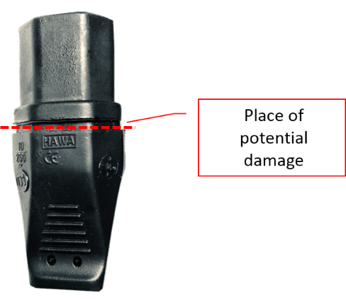
Figure 1 Place of potential damage

How to identify affected power cords
Only power cords, which meets ALL of the following criteria, are potentially affected:
- Only European version of the power cord is affected.
- Originally the power cord has been shipped together with one of the before mentioned products
- Power cord must be from our 3rd party supplier HAWA. The supplier name is printed on device connector and mains plug (see figure 2 below).
- Power cords are labelled with the manufacturing date on the mains plug (see figure 2 below). Only power cords manufactured between July 2016 (marked as M7 Y6) and June 2018 (marked as M6 Y8) are affected.

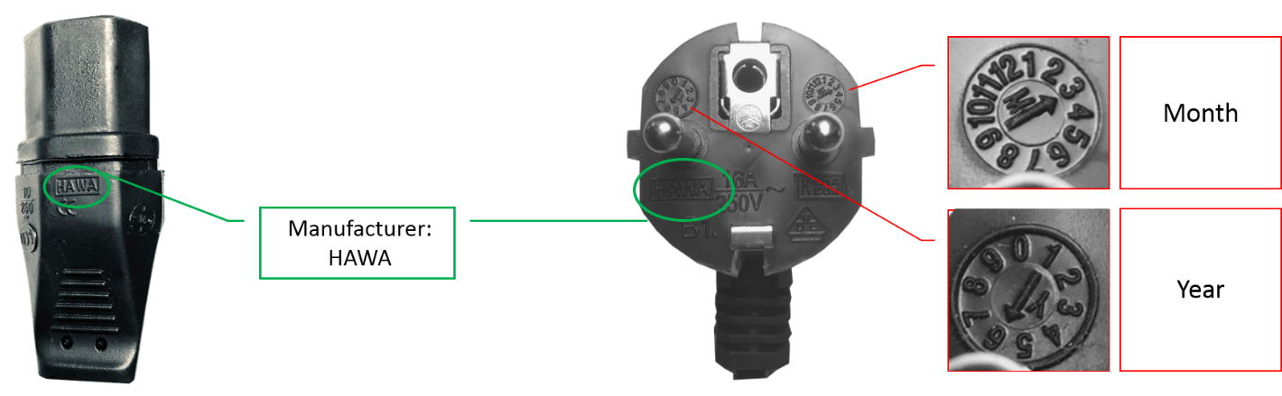
Figure 2 Identification of manufacturer and batch

Actions to be taken
- Confirm the receipt of this information.
- Inform the responsible personnel in the affected areas of your facility. If you are a distributor please forward this FSCA to affected customers.
- Remind all users of good practice with electrical equipment.
- We recommend to identify affected power cords in your hospital and replace them. Take broken power cords out of service immediately.
- Please contact your local sales representative to receive free replacements for affected power cords
- If you wish to continue to use affected power cords, please avoid improper handling such as heavy lateral force under all circumstances.

If more information is needed, please contact

Local contact 1  Name  Title  Email  telephone | Local contact 2

Kindly accept our apologies for any inconvenience.

Yours sincerely,

