Product: Peek Acuity Pro App

Product Affected:

Product | Product Code | Software Version
Peek Acuity Pro App | PV_PAC_001 | 3.5.2

Dear Customer,

The purpose of this letter is to inform you about a potential issue identified with the Peek Acuity Pro app.

Peek Vision has discovered that some Android devices are misreporting pixel density, a measure of a device’s screen resolution. Peek Acuity Pro vision check app uses pixel density to calculate the correct size for the letters in the “tumbling E” vision chart on which the app is based.

On devices which misreport pixel density, this leads to incorrect sizing for the letters on which the vision check is based, which could lead to inaccurate results.

As far as Peek Vision are aware, the problem of some Android devices misreporting pixel density hasn’t been identified previously. It affects not just the Peek Acuity Pro app, but other applications which use the same method to produce accurate sizing, such as “ruler” apps.

This Field Safety Notice is intended to inform you about:

- the description of the issue
- the actions planned by Peek Vision to correct the issue
- the actions that should be taken by the customer

This document contains important information for the continued safe and proper use of your software

Please refer to the following page which provides the details of the problem and instructions for actions to be taken. Please follow the instructions in the “Actions to be Taken by Customer/User” section.

We sincerely regret the inconvenience that this may cause you. Peek Vision is committed to providing products and services of the highest quality. Your satisfaction with Peek Vision products and with our response to this issue is very important to us.

This notice has been reported to the appropriate Regulatory Agencies.

If you have any questions about this matter, please contact Peek Vision by emailing enquiries@peekvision.org or visit the website https://www.peekvision.org/en_GB/get-involved/contact-us/

Sincerely,

Jamie Wallis

Risk & Compliance Manager

Product Affected:

Product | Product Code | Software Version
Peek Acuity Pro App | PV_PAC_001 | 3.5.2

Issue/Problem:

Peek Vision has discovered that some Android devices are misreporting pixel density, a measure of a device’s screen resolution. Peek Acuity Pro vision check app uses pixel density to calculate the correct size for the letters in the “tumbling E” vision chart on which the app is based.

On devices which misreport pixel density, this leads to incorrect sizing for the letters on which the vision check is based, which could lead to inaccurate results.

As far as Peek Vision are aware, the problem of some Android devices misreporting pixel density hasn’t been identified previously. It affects not just the Peek Acuity Pro app, but other applications which use the same method to produce accurate sizing, such as “ruler” apps.

Actions to be Taken by Customer/User:

Note: The following is detailed on the company website as well:

https://www.peekvision.org/en_GB/peek-solutions/peek-acuity/peek-acuity-calibration

Calibrating your device for Peek Acuity:

To find out whether your device is affected, you'll need a normal metric ruler or measuring tape with millimetre (mm) measurements.

The calibration check should pop up automatically once you've updated the app. If it doesn't appear automatically, or if you want to perform calibration more than once, go to the Settings menu in the app, and select Check Calibration:
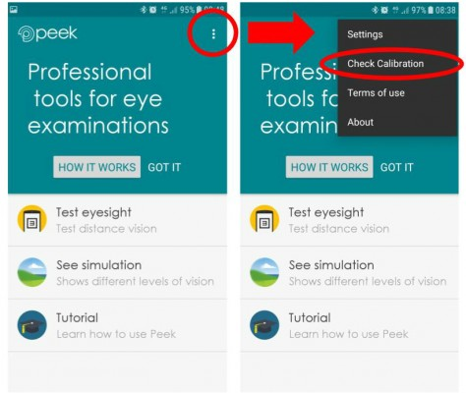
When the calibration window opens, you'll be prompted to measure the width and height of the "E" symbol:
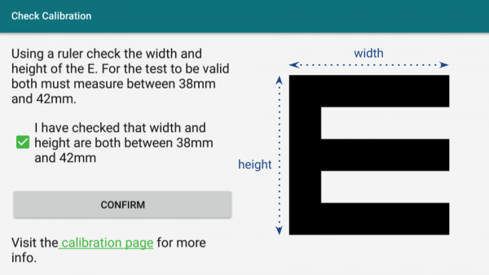

Using a ruler or measuring tape, measure the dimensions of the E symbol as shown here:
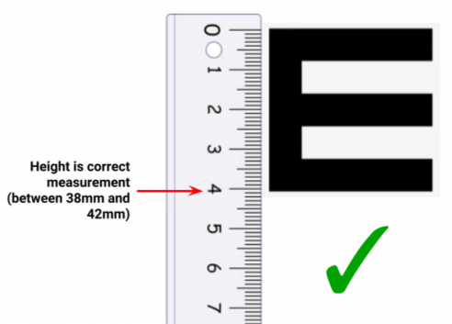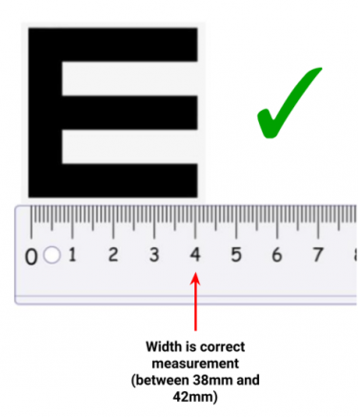

If both width and height measurements are correct, check the box to confirm that both width and height are correct, and then you can continue to use Peek Acuity with confidence that the results will be at least as accurate as conventional vision charts.
If either or both measurements are not between 38mm and 42mm, please do not use your device to conduct Peek Acuity vision checks, as the results will be inaccurate.
If you use any other apps which rely on accurate measurement (e.g. a "ruler" app), you may find that accuracy is similarly affected.

Peek Vision are working on a new way to produce accurately sized letters in Android devices which doesn’t rely on pixel density. Peek Vision will update the apps as soon as this is ready, but in the meantime, please be sure to calibrate the app before performing Peek Acuity distance vision checks.

If you have any questions or concerns, please read the calibration frequently asked questions, or contact Peek Vision.

Individual devices of the following models have been observed to be affected:

- Samsung J5 (2015)
- Huawei MediaPad T3 7" Tablet

Peek Vision do not know whether all devices of these model’s misreport pixel density, so please perform the calibration check described above even if you are using one of these models.

Actions Taken by Peek Vision:

As described above, Peek Vision has released an update to Peek Acuity Pro (3.5.13) that enforces the users to perform a calibration step to identify if their device is functioning correctly by using a ruler or measuring tape to confirm the size of "E" generated by the test.

Peek Vision is notifying affected customers with this document through our website, the Google Play store, and all customers should receive a device notification to update the app which enforces the calibration step.

