Field Safety Notice
Immediate actions to mitigate problems encountered in clinical use

FSCA Identifier |  |  | FSN2018040XX
Type of Action |  |  | Immediate Product Recall
1. The immediate recall of the products applies first.
2. The user should use appropriate alternative products. The compatible machine information is listed as below to support the finding of alternative replacing products.
3. If the user does not see the possibility of using alternative products, the physician can decide to continue to use the concerned products with appropriate monitoring of the treatment.

Affected Devices |  |  | NovaLine® Tubing Sets for Hemodialysis
Product Code | Model  Name | HD- Monitor | Lot #
955443 | BL 106 | Baxter AK 95 S, AK 96, AK 98,  AK 200 S & AK 200 ULTRA S | All lots of the model manufactured in year 2017  "2017XXXXXXXX"
955446 | BL 224 | Baxter AK 200 S and AK 200 ULTRA S
955307 | BL 24 | Baxter AK 95 S, AK 96, AK 98,  AK 200 S
955445 | BL 208 | Baxter AK 200 S and AK 200 ULTRA S
955448 | BL 207 | Baxter AK 96, AK 98, AK 200 S,  AK 200 ULTRA S
955447 | BL 211 SN | Baxter AK 200 S, AK 200 ULTRA S
955305 | BL 148 SN | Baxter AK 200 S, AK 200 ULTRA S
955444 | BL200 HDF | Baxter AK 200 ULTRA S
955300 | BL 10R | Baxter AK 95 S, AK 96, AK 98,  AK 200 & AK 200 ULTRA
955449 | BL 245 | Baxter AK 95 S, AK 96, AK 98,  AK 200 S & AK 200 ULTRA S

Date |  | April 2018
Attention |  | Distributors and Users in XXX (relevant Country)
Dear Customers,

Vital Healthcare has identified the possibility of abnormal device behaviors of the NovaLine® Tubing Sets for Hemodialysis listed above.

Under certain rare circumstances, the device may exhibit the following behaviors:
- Configuration / Assembling issues (i.e. disconnected, not proper fitting between components, component missing)
- Functional issues (i.e. air entrance, difficulties to manage pressure monitoring during treatment)
- Clotting issues

Vital Healthcare has taken the customer feedback very seriously and conducted a thorough and detailed investigation to better understand the circumstances of the reported events.

The Annex 1 provides the “Description of the Device Deficiency” including clarification of the potential hazard associated with the device and the associated risk to the patient, user or other person and any possible risks to patients associated with previous use of affected devices. Advice on actions to be taken by the user is also listed in this section.

Vital Healthcare apologizes for any inconvenience this may cause you. If you have questions regarding this notification or need any further information or support, please contact Baxter.

Vital Healthcare Sdn. Bhd. confirms that the competent authority has been informed of this Field Safety Notice.

Transmission of this Field Safety Notice:
Please send this notice to all concerned persons of your organization and / or organization where the products were transferred.

Please check the application of this notice to ensure the effectiveness of corrective measures recommended.
Regards

Vital Healthcare Sdn. Bhd.

Annex 1: Description of the Device Deficiency

Klang, 20/04/2018 Mu Fangzhen, Management Representative
Place, Issue Date Name, Function

Annex 1 Description of the Device Deficiency

Action to be Taken by Customers

Problems 1 Description |  | One occurrence in which blood pump of the machine didn’t automatically stopped when blood reaches the venous extracorporeal blood circuit.  Cause: It might be due to that this extrusion tubing is not same transparent as other tubes and the hemodialysis machine cannot identify the presence of blood in this tubing.  Potential Risk: Blood loss
Action to be Taken by Customers / Users |  | Operator must take care about blood pump stopping when the blood reaches the venous drip chamber. If the operator recognizes that is not going to happen once the blood arrive at the right level along the venous line, operator has to stop the blood pump manually and then connect the patient
Actions planned by Vital Healthcare |  | Considering there is only one incident reported about this problem and the treatment continues without any further problem when the operator manually stopped the pomp. Vital Healthcare will keep monitoring the market feedback. In the meantime, it will keep ensuring the tubing is transparent.
Problems 2 Description |  | An exceptionally rare event of kinking of the blood pump segment  Cause: This might be caused by the worker’s improper tubing placing and the inspector fails to pick it out during 100% final product inspection and sampling inspection.  Potential Risk: Hemolysis
Action to be Taken by Customers / Users |  | Operator must check the presence of kinking all along the bloodline before use. In case the operator recognizes the presence of kinking, the tubings must be scrapped.  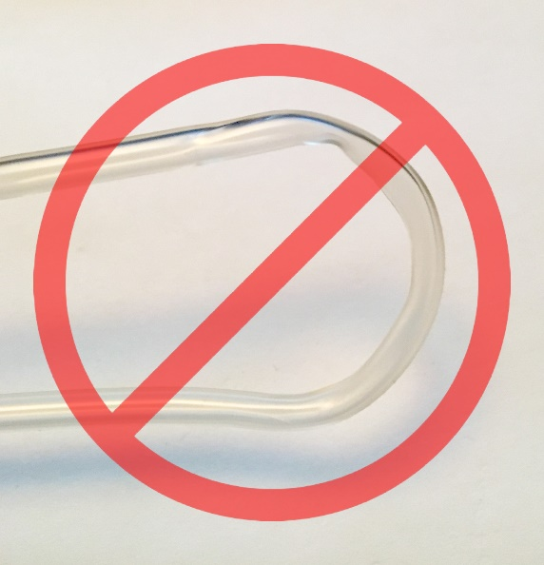
Actions Planned by Vital Healthcare |  | Re-train the workers on tubing rolling process as well as workers on 100%  final inspection of finished products
Problems 3 Description |  | Some events of loose component inside primary packaging such as detached drainage bag and detached Transducer Protector (TP)  Cause: Improper operation of the worker. Components may not be tightly screwed during production and become loose after long time transportation.  Potential Risk: Contamination / Infection / Clotting
Action to be Taken by Customers / Users |  | Operator must check the presence of detached components before open the primary packaging and take care during packaging opening that no loose components fall on contaminated surfaces (i.e floor).  - If loose components fall onto the floor they must be scrapped and a entire new bloodline must be used.  - If detached bags or TP are found inside primary packaging it could be easily reconnected.
Actions Planned by Vital Healthcare |  | Retrain the workers. Increase the sampling amount for inspection.
Problems 4 Description |  | Rare events of air entrance in the extracorporeal blood circuit. Majority parts of the events involve the transducer protector. The first TP was glued to the tubing and the second TP was screwed to the first TP manually. The second TP might not be firmly connected.  Cause: Improper operation of the worker. Components may not be tightly screwed during production and become loose after transportation. If the connection is not tightened by operator according to section 5.4 of the manual, air entrance may occur.  Potential Risk: Clotting
Action to be Taken by Customers / Users |  | Operator must check the tightening of all the bloodlines connection before use according to section 5.4 of relevant product Instructions for Use. The critical connection to check is illustrated below:  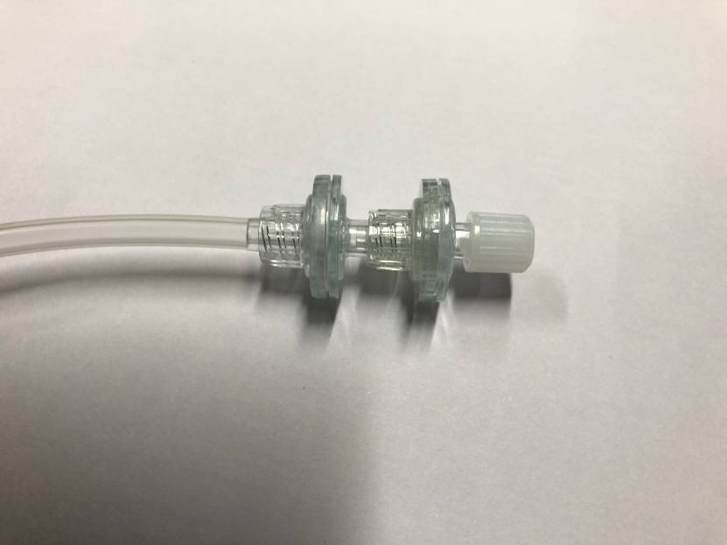
Actions Planned by Vital Healthcare |  | The double TP should be glued to ensure they’re leak-proof and reduce the risk
Problems 5 Description |  | Rare events of not proper fitting between arterial chamber and machine holders.  Cause: There are different machine holder types for arterial chamber. One machine holder has several holes/places for fitting different chamber types.  The arterial chamber may be placed at wrong hole/place of the machine holder and is not properly fitted in.  Potential Risk: The falling-down of the chamber from the machine holder. The air at the top of the chamber may come into the bloodline circuit.
Action to be Taken by Customers / Users |  | Operator must check that the arterial chamber is placed at the right hole of the holder suiting its size and is properly fitted in.
Actions Planned by Vital Healthcare |  | Develop an arterial chamber with same size as the ones that the users used previously.
Problems 6 Description |  | Rare events of not proper fitting between venous chamber and machine holders.  Cause: The involved materials are harder than the lines which they used previously.  Potential Risk: Difficulty to close the machine holder, malfunction on the air bubble detection.
Action to be Taken by Customers / Users |  | Operator must check that the venous chamber is clamped/ fastened surely
Actions Planned by Vital Healthcare |  | Reduce the material rigidness.
Problems 7 Description |  | Some events of clotting occurred.  Causes:  - The double transducer protector is loosely screwed, causing air entrance in the tubing and clotting.  - If the blood volume level inside the arterial chamber and venous chamber is too high, the blood on top may get stagnant, which leads to clotting.  - The clamp does not clamp tight, causing blood level inside the chamber to increase and the blood at surface may become stagnant, which may cause clotting.  - NovaLine tubing’s venous chamber filter is short filter, which may not allow too much blood pass through the filter at same time. When the blood volume is big at the venous chamber, the blood surface in the venous chamber may become clotted.  - The drip chamber does not attach to the machine clamp well, causing the air alarm and clotting after pump stops.  Potential Risk: Blood Loss
Action to be Taken by Customers / Users |  | Adjust the anti-coagulation prescription if necessary. Monitor the blood volume inside the chamber, it is recommended the blood volume inside arterial chamber should be no more than 2/3 of the chamber volume and the blood volume/surface inside the venous chamber should be at same level as the dropper end. Once when coagulation is observed (by visual check or by an increasing venous pressure detected by monitor), stop the treatment, rinse back blood to patient in a safe manner and change the circuit according to indications provided by relevant Instructions for Use.
Actions Planned by Vital Healthcare | 1. Change the dropper to be longer.  2. Change the clamp to clamp of another type with better closure.  3. Change the short filter of the venous chamber to long filter.  4. Decrease the rigidity of the venous chamber so that it can be better attached to the machine holder.  5. Change the double TP to be glued together (to be investigated).

Action to be Taken by Customers / Users
- The immediate recall of the products applies first. Remove any affected (recalled) product from your inventory (whether in Warehouse, Central Supply, Shipping and Receiving or ANY other location). The user should use appropriate alternative products. If the user does not see the possibility of using alternative products, the physician can decide to continue to use the concerned products with appropriate monitoring of the treatment.

- Segregate this product in a secure location for return to the local supplier／Baxter／Vital Healthcare Sdn. Bhd.

- Forward a copy of this Field Safety Notice to all sites to which you have distributed affected product.

- Package any product that is being returned in an appropriate shipping box and contact the local distributor to collect.

