Field Cybersecurity Routine Update and Patch Notice
ETHICON Generator Gen11

[Date]

Dear Operating Room Supervisors, Risk Managers, Biomeds, and Materials Management Personnel:

PLEASE DISTRIBUTE THIS INFORMATION TO ALL STAFF WITHIN YOUR FACILITY WHO USE THE ETHICON GEN11 GENERATOR.

Ethicon Endo-Surgery, LLC (Ethicon) has confirmed a cybersecurity software vulnerability on your Ethicon Generator Gen11 (Gen11) and is issuing a field cybersecurity routine update and patch to address that cybersecurity software vulnerability to your Gen11. This cybersecurity software vulnerability can exist when using the Gen11 system with certain non-OEM disposable devices (as defined below) as it is possible for these devices to bypass the Gen11 security authentication. This cybersecurity software vulnerability has been assessed to have a sufficiently low (acceptable) residual risk of patient harm because the Gen11 has additional safeguards in place to protect the patient even though it is possible for the Gen11 security authentication to be bypassed. The Gen11 does not have wireless connection and does not connect to any IT networks. The generator does not store any patient records and there is no impact on patient privacy.
After the update of the Gen11 to address the cybersecurity software vulnerability, some of your non-OEM products may no longer work on the Gen11. Non-OEM devices are devices that have not been manufactured or reprocessed by Ethicon or Sterilmed, Inc (Sterilmed). OEM Ethicon (including Sterilmed) devices will continue to function as designed on the Gen11 systems.

The Gen11 system was designed for use only with OEM Ethicon (including Sterilmed) devices and therefore we cannot ensure that the generator will function properly when used with any non-OEM devices, as referenced in our User Manual Warnings and Precaution section:

Products manufactured or distributed by companies not authorized by Ethicon Endo-Surgery may not be compatible with the HARMONIC system. Use of such products may lead to unanticipated results and possible injury to the user or patient.

We strongly recommend complying with the Gen11 product labeling and using only OEM devices on the Gen11. Use of non-OEM devices may void the generator warranty.

This vulnerability represents a low risk of harm to patients, so health care practitioners who have treated patients using the Gen11 may continue to follow those patients post-operatively in the usual manner.
We recognize that this upgrade may be disruptive to your facility and we apologize for any inconvenience this may cause. Please contact your Ethicon sales representative or Ethicon Customer Support Center at 1-877-ETHICON should you have any questions.
For customers concerned about the Cybersecurity of Products of the Johnson & Johnson Family of companies, please visit http://productsecurity.jnj.com.

IDENTIFICATION OF PRODUCT SUBJECT TO THIS CORRECTION:

Product subject to this can be identified using the Product Identification Tool seen in Attachment 1

ACTION REQUIRED FOR CUSTOMERS:

- Examine your inventory to determine if you have any Ethicon Gen11 Generators. The Product Identification Tool in Attachment 1 can be used to identify Ethicon Gen11 Generators.
- Please complete the Business Reply Form (Attachment 2) and fax or email it to [Affiliate Phone number and email address]] within five (5) business days. Please return the BRF even if you do not have an Ethicon Gen11 Generator.

  - Customers who respond that they have Ethicon Gen11 Generator(s) to be updated will be contacted by their Ethicon sales representative to schedule the update for their generator.
- Keep this notice visibly posted for awareness until all Ethicon Gen11 Generators at your facility have been upgraded.

PLEASE RETURN THE BRF WHETHER OR NOT YOU HAVE an Ethicon Gen11 Generator.

If you have additional questions regarding this medical device correction (notification) or to report any customer complaints, please contact Ethicon Customer Support Center at 1-877-ETHICON (1-877-384-4266) Monday – Friday 7:30 AM – 6:30 PM EST. If you need an additional communications letter, contact the Stericycle support center at 1- 855-215-4972.

As with any medical device, adverse reactions or quality problems experienced with the use of this product should be reported to the FDA's MedWatch Adverse Event Reporting program online, by regular mail or by fax:

• Online: www.fda.gov/medwatch/report.htm

• Regular Mail:
Use postage-paid FDA form 3500 available at: www.fda.gov/MedWatch/getforms.htm
Mail to: MedWatch 5600 Fishers Lane, Rockville, MD 20852-9787

• Fax: 1-800-FDA-01

ATTACHMENTS:

Attachment 1: Product Identification Tool
Attachment 2: Business Reply Form (BRF)

ATTACHMENT 1: Product Identification Tool for ETHICON
Gen11 Generator

This tool will help customers identify the products subject to this correction by using the graphics below. This document applies to Ethicon Gen11 Generators.
Front View of Ethicon Gen11 Generator

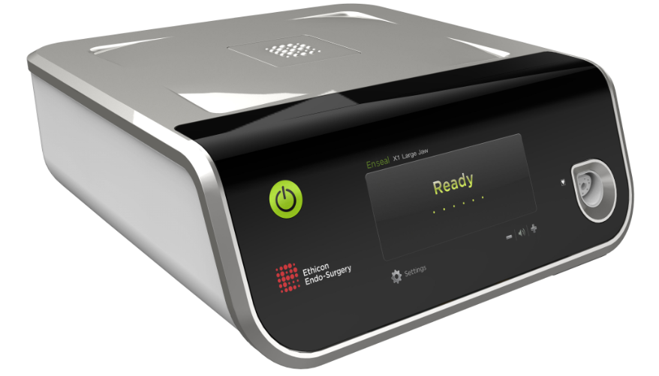

Rear View of Ethicon Gen11 Generator

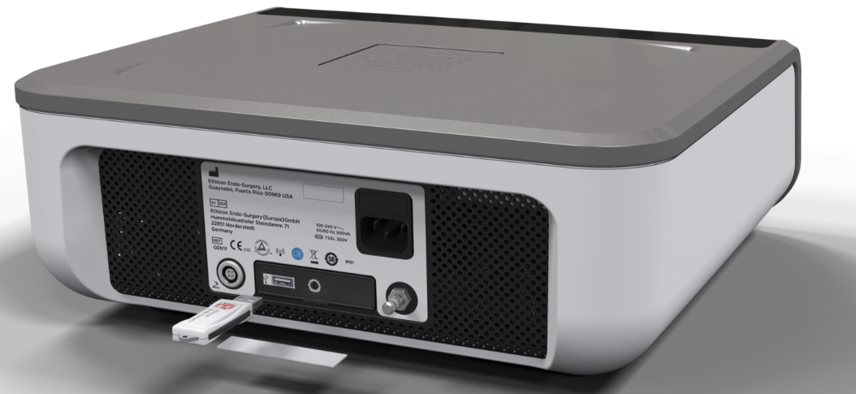

Ethicon Gen11 Generator Label

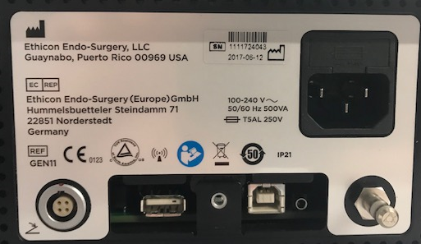
Product Code

Serial
Number

ATTACHMENT 2: Business Reply Form (BRF)

Your timely response to this customer notification is requested. Please complete this form and fax or email it to [Affiliate Phone number and email address] within 5 business days, even if you do not have product subject to this notification.

Please complete the following information:

We hereby acknowledge receipt of this medical device notification letter from Ethicon regarding the Ethicon Gen11 Generator. We have distributed this information to all staff within our facility that use the affected products and will maintain a copy of this notice with the identified product(s).

Product Receipts – please check one:
- We do not have any Ethicon Gen11 Generators; however, we will maintain a copy of this notice within our facility.
- We have Ethicon Gen11 Generator(s) subject to this notification and would like to schedule the software to be updated by an Ethicon sale representative. We have updated the table below with the Ethicon Gen11 Generator serial numbers that we have on site. (Attachment 1 is the product identification tool that can help identify the Ethicon Gen11 Generator and serial number location.)
- We have Ethicon Gen11 Generator(s) subject to this notification and do not authorize the software to be updated by an Ethicon sale representative. We acknowledge that the generator may not function properly, and/or as designed, should this cybersecurity software vulnerability remain unresolved. We have updated the table below with the Ethicon Gen11 Generator serial numbers that we have on site.
  - Please be advised that generators that are returned for service will be updated with the latest version of software. This will include the update that addresses the cybersecurity software vulnerability.
Ethicon Gen11 Generator Serial Numbers
Serial Numbers | Serial Numbers
Note: If you need to add additional serial numbers, please copy this form to complete.
[Account Name], [Account Address]
Print Name of Person Completing Business Reply Form: | Telephone Number:
Account Number:  (number used to order J&J product) | Date:
Signed*:

*Your signature provides confirmation that you have received and understood this notification
Your comments are welcome:

