URGENT: FIELD SAFETY CORRECTIVE ACTION

February 8, 2021

PHIL TM (Precipitating Hydrophobic Injectable liquid)

Dear Customer,

MicroVention has initiated a voluntary Field Safety Corrective Action (FSCA) for PHIL products packaged in recently introduced tray packaging configuration. MicroVention has identified a potential issue with the immediate PHIL container (syringe) in tray packaging configuration which may elute unintended elements into PHIL device formulation. All other packaging configurations of PHIL devices (pouches) are not included in or affected by this FSCA.

Products Included In FSCA

The FSCA concerns the following PHIL model names, numbers, and specific lot numbers:

Catalog Number | Product Name | Concentration | Product Barcode
LEN10250 | PHIL Starter Kit | 25% | 0100842429101490
LEN10300 | PHIL Starter Kit | 30% | 0100842429101506
LEN10350 | PHIL Starter Kit | 35% | 0100842429101513
LEN10LV250 | PHIL Starter Kit | 25% | 0100842429101520
LEN10250RE | RePHIL | 25% | 0100842429101537
LEN10300RE | RePHIL | 30% | 0100842429101544
LEN10350RE | RePHIL | 35% | 0100842429101551
LEN10LV250RE | RePHIL | 25% | 0100842429101568

PRODUCT SUBJECT TO FSCA
PHIL™ Tray

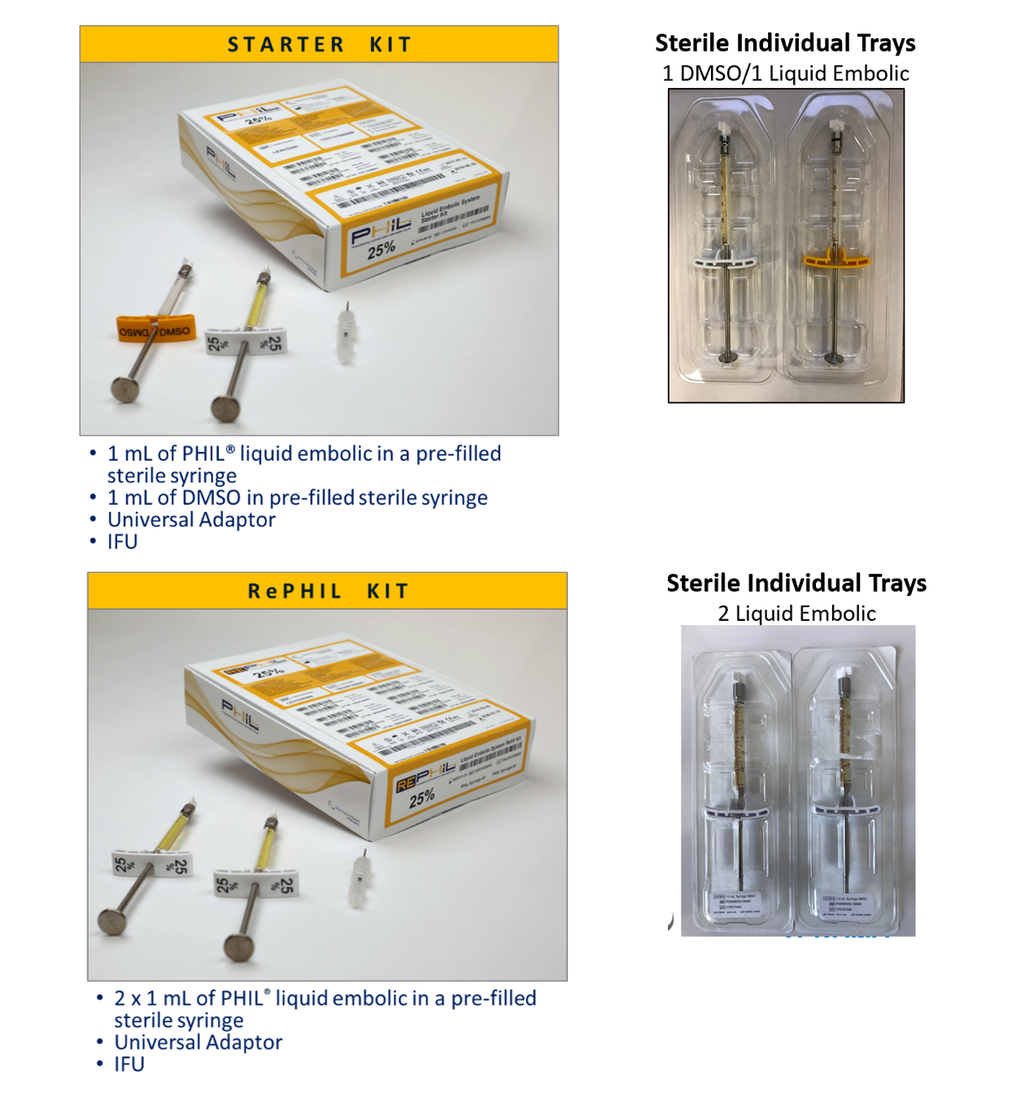

PRODUCT NOT AFFCTED BY FSCA

PHIL™ Pouch
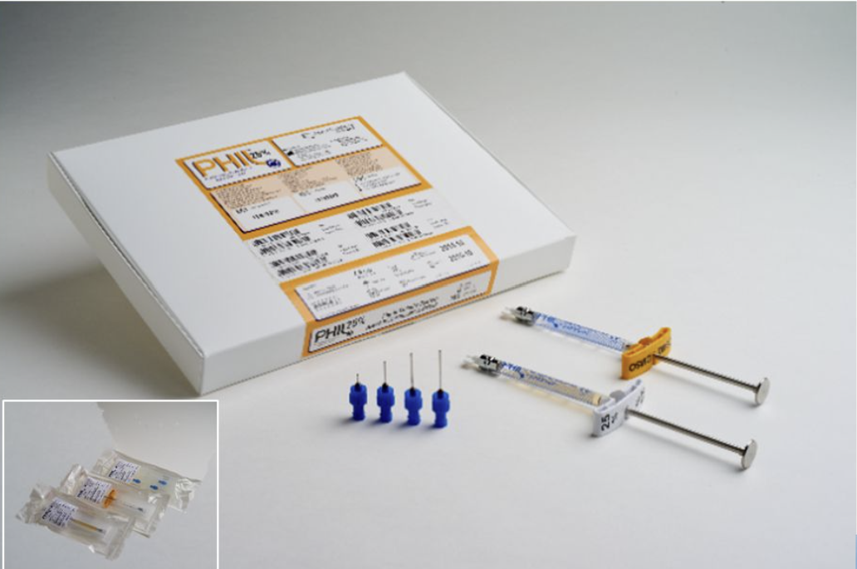

Product intended use:
- PHILTM (Precipitating Hydrophobic Injectable Liquid) System is intended for use in the embolization of lesions in the peripheral and neurovasculature, including arteriovenous malformations and hypervascular tumors.

Description of the Issue:

It was determined that the PHIL container (syringe) may elute unintended elements (metals) into PHIL device formulation.
- There were no adverse events reported to the manufacturer with regard to this particular concern. Nor has MicroVention identified any specific risks to patients associated with the previous uses of PHILTM devices. MicroVention will continue to monitor any adverse events related to the issue.

The following actions are to be taken by the user:
- Identify list of affected products in your inventory and cease use of the listed products.
- Account for products used.
- Complete and return the applicable “ACKNOWLEDGEMENT AND RECONCILIATION FORM” to the email contact below – immediately upon receipt.

Your competent authority has been informed about this Field Safety Notice.

Please direct any questions to MicroVention contact below:
Julie Lopez
Sr. Manager QA/RA EMEA
MicroVention Europe SARL, A TERUMO Group Company
30 bis rue du Vieil Abreuvoir, 78100 Saint-German-en-Laye, France
Ph. +33(1)39 21 77 46; Fax +33(1)39 21 16 01
Email: MVEMEAQARA@microvention.com

We regret any convenience that this action may cause, but we appreciate your understanding as we take action to ensure patient safety and customer satisfaction.

Sincerely,

Irina Kulinets, PhD, RAC
Sr. Vice President of Regulatory Affairs, Clinical Research, and Quality
MicroVention Inc., A TERUMO Group Company

Enclosures:
Attachment 1 – List of potentially affected product lots
Attachment 2 – Acknowledgement and Reconciliation Form

Attachment 1: List of Affected Lots
(Ref : FCA# 2021-01)
Product Name | PHILTM (Precipitating Hydrophobic Injectable liquid)
Catalog # | LEN10250, LENI1025RE, LEN10300, LEN10300RE, LEN10350, LEN10350RE, LEN10LW250, LEN10LV250RE

Catalog # | LEN10250 | LEN10250RE | LEN10300 | LEN10300RE | LEN10350 | LEN10350RE | LEN10LV250 | LEN10LV250RE
Lot # | 19021214LM | 19080514R | 190307122M | 19080514X | 19021214PM | 19080514Y | 190103126 | 190103131
 | 190805135 | 19080514T | 19080514L | 19102114P | 19080514N | 190903125 | 190121124 | 19041211Q
 | 19080514J | 19080514W | 19090512C |  | 19090512J | 190924122 | 19031111T | 19080513A
 | 19080514K | 19090311Z | 190924123 |  | 190924124 |  | 190722133 | 19090313N
 | 19090511Q | 190903121 | 19102114G |  | 19102114H |  | 19072312T | 19092411Z
 | 19090511R | 190903122 | 191106142 |  | 19110613X |  | 19080512Z | 19102114T
 | 19090511T | 190903123 | 200203132 |  | 200203133 |  | 190924121 | 19110614H
 | 190905127 | 19092311E | 20070912E |  | 20072811R |  | 19102114R | 200819129
 | 190923119 |  | 20080612Q |  | 20072811RM |  | 191106149
 | 19092311A |  | 20081911YM |  | 1907091DP |  | 200110123
 | 19092311B |  | 1907091DN |  |  |  | 20030911U
 | 19092311C |  |  |  |  |  | 200518138
 | 19102114B |  |  |  |  |  | 200518138M
 | 19102114C |  |  |  |  |  | 20052813E
 | 19102114E |  |  |  |  |  | 20052813F
 | 19102114F |  |  |  |  |  | 20070912L
 | 191106135
 | 191106136
 | 191106137
 | 20032511T
 | 200519119
 | 20051911A
 | 200521127
 | 200521128M
 | 20070111Y
 | 20070912X
 | 20070912Y
 | 200727116
 | 200727117
 | 20072811H
 | 20081911F
 | 20101515G
 | 20101914A
 | 1907091DL
 | 2002181DG

DISTRIBUTOR FIELD SAFETY CORRECTIVE ACTION
ACKNOWLEDGMENT AND RECONCILIATION FORM

DISTRIBUTOR NAME: _____________________________________________

ADDRESS: ______________________________________________________

DISTRIBUTOR CONTACT PHONE #: __________________________________

We have read and understood the Field Safety Corrective Action letter issued by MicroVention Inc. regarding the PHILTM (Precipitating Hydrophobic Injectable Liquid) devices. We have immediately disseminated this Field Safety Corrective Action letter to the affected customer(s), have requested the affected customers to complete the Customer Field Safety Corrective Action Acknowledgment and Reconciliation form, and to arrange proper return of all unused units.

We have checked our stock and will be returning the quantity indicated in the table below.

Catalog # | Lot # | Quantity Received | Quantity Used* | Quantity to be Returned
*Quantity Used includes products that were used, opened in error, returned to manufacturer as product complaints, or discarded.

Representative Name (Print Name) | Signature | Date

PLEASE EMAIL THE COMPLETED FORM to mvexportcustomerservice@microvention.com.

For returned product – our customer service will provide instructions for product return.

--------------------------------------------- Internal use only (below) ---------------------------------------------
RGA#:_______________________
CUSTOMER FIELD SAFETY CORRECTIVE ACTION
ACKNOWLEDGMENT AND RECONCILIATION FORM

CUSTOMER NAME: ___MEDFAU sh.p.k___________________________________________

ADDRESS: ______________________________________________________

CUSTOMER CONTACT PHONE #: ___________________________________

We have read and understood the Field Safety Corrective Action letter issued by MicroVention Inc. regarding the PHILTM (Precipitating Hydrophobic Injectable Liquid) devices. We have taken the appropriate action and disseminated this information to any affected staff, service and/or facilities.

We have checked our stock and will be returning the quantity indicated in the table below.

Catalog # | Lot # | Quantity Received | Quantity Used* | Quantity to be Returned
 |  | 1
*Quantity Used includes products that were used, opened in error, returned to manufacturer as product complaints, or discarded.

Representative Name (Print Name) | Signature | Date

PLEASE EMAIL THE COMPLETED FORM to mvfrance.customerservice@microvention.com.

For returned product – our customer service will provide instructions for product return.

--------------------------------------------- Internal use only (below) ---------------------------------------------

RGA#:_______________________
CUSTOMER FIELD SAFETY CORRECTIVE ACTION
ACKNOWLEDGMENT AND RECONCILIATION FORM

CUSTOMER NAME: ______________________________________________

ADDRESS: ______________________________________________________

CUSTOMER CONTACT PHONE #: ___________________________________

We have read and understood the Field Safety Corrective Action letter issued by MicroVention Inc. regarding the PHILTM (Precipitating Hydrophobic Injectable Liquid) devices. We have taken the appropriate action and disseminated this information to any affected staff, service and/or facilities.

We have checked our stock and will be returning the quantity indicated in the table below.

Catalog # | Lot # | Quantity Received | Quantity Used* | Quantity to be Returned
*Quantity Used includes products that were used, opened in error, returned to manufacturer as product complaints, or discarded.

Representative Name (Print Name) | Signature | Date

PLEASE EMAIL THE COMPLETED FORM to janet.stonehouse@microvention.com.

For returned product – our customer service will provide instructions for product return.

--------------------------------------------- Internal use only (below) ---------------------------------------------

RGA#:_______________________
CUSTOMER FIELD SAFETY CORRECTIVE ACTION
ACKNOWLEDGMENT AND RECONCILIATION FORM

CUSTOMER NAME: ______________________________________________

ADDRESS: ______________________________________________________

CUSTOMER CONTACT PHONE #: ___________________________________

We have read and understood the Field Safety Corrective Action letter issued by MicroVention Inc. regarding the PHILTM (Precipitating Hydrophobic Injectable Liquid) devices. We have taken the appropriate action and disseminated this information to any affected staff, service and/or facilities.

We have checked our stock and will be returning the quantity indicated in the table below.

Catalog # | Lot # | Quantity Received | Quantity Used* | Quantity to be Returned
*Quantity Used includes products that were used, opened in error, returned to manufacturer as product complaints, or discarded.

Representative Name (Print Name) | Signature | Date

PLEASE EMAIL THE COMPLETED FORM to Office@microvention.de .

For returned product – our customer service will provide instructions for product return.

--------------------------------------------- Internal use only (below) ---------------------------------------------

RGA#:_______________________

CUSTOMER FIELD SAFETY CORRECTIVE ACTION
ACKNOWLEDGMENT AND RECONCILIATION FORM

CUSTOMER NAME: ______________________________________________

ADDRESS: ______________________________________________________

CUSTOMER CONTACT PHONE #: ___________________________________

We have read and understood the Field Safety Corrective Action letter issued by MicroVention Inc. regarding the PHILTM (Precipitating Hydrophobic Injectable Liquid) devices. We have taken the appropriate action and disseminated this information to any affected staff, service and/or facilities.

We have checked our stock and will be returning the quantity indicated in the table below.

Catalog # | Lot # | Quantity Received | Quantity Used* | Quantity to be Returned
*Quantity Used includes products that were used, opened in error, returned to manufacturer as product complaints, or discarded.

Representative Name (Print Name) | Signature | Date

PLEASE EMAIL THE COMPLETED FORM to mvexportcustomerservice@microvention.com.

For returned product – our customer service will provide instructions for product return.

--------------------------------------------- Internal use only (below) ---------------------------------------------
RGA#:_______________________

