PLEASE DELIVER UPON RECEIPT to LAB DIRECTOR or LAB MANAGER

[to be date of distribution]

Urgent Field Safety Notice

Our Ref: 4318 FSCA
Dear Valued bioMérieux Customer,

Our records indicate that your laboratory uses the VITEK® 2 System in conjunction with the VITEK 2 AST-N254, AST-N330 and/or AST-N371 test kit.

TABLE 1: VITEK® 2 AST Test Kits

REF # | Product Name | Lot #
413723 | VITEK® 2 AST-N254 Test Kit | All lot numbers
418674 | VITEK® 2 AST-N330 Test Kit | All lot numbers
422024 | VITEK® 2 AST-N371 Test Kit | All lot numbers

Description of Issue:
bioMérieux has identified the potential for an unexpected ESBL (Extended Spectrum Beta Lactamase) phenotype to be proposed for some Escherichia coli strains in conjunction with the VITEK® 2 AST-N254, AST-N330 and AST-N371 test kits (ref. 413723, 418674 and 422024, respectively).

When an ESBL phenotype is proposed by VITEK 2 Systems Software AES (Advanced Expert System™), the system will stop the result for review by the user. The intent of the review is that the laboratory personnel take measures to confirm the proposed ESBL phenotype is consistent based on all information available, and perform confirmatory testing if deemed appropriate.

Internal investigations concluded that within the VITEK 2 Systems Software version 8.01 (and subsequently 9.01) AES modules, the MIC (Minimum Inhibitory Concentration) ranges for Escherichia coli and piperacillin/tazobactam were changed for the ‘Acquired Penicillinase’ and ‘Inhibitor Resistant Penicillinase’ phenotypes.

This change revealed an issue in the AES definition of the cefuroxime MIC range for Escherichia coli and the ESBL phenotypes (ESBL, or ESBL [CTX-M-like]); the MIC range is too broad (a cefuroxime MIC <=8 mg/L should prevent the ESBL phenotype proposal). This, in addition to the specific antibiotic configuration of the AST-N254, AST-N330 and AST-N371 cards, and absence of the ESBL Test, is the root cause of the potential for an unexpected ESBL phenotype proposal for the AST-N254, AST-N330 and AST-N371 cards.

Implementation of a bioART™ rule with the following criteria will prevent inappropriate proposal of the ESBL phenotype related to this anomaly (reference Appendix A for detailed instructions):
- If the card is AST-NXXX (where XXX indicates the card type designation, 254 / 330 / 371)
- The organism is Escherichia coli
- And the phenotype is ESBL
- And the drug cefuroxime is <=8
- And the drug ceftazidime is <=0.5
- Then stop for consultation and add a comment: “There is no evidence that the isolate is an ESBL producer. The category results for cephalosporins should be interpreted as tested, before the AES expertise.”
Impact to patient/user:
Due to the described anomaly, there is the potential for inconvenience to the user in the form of increased review of patient results prior to submitting the results to the physician.

If there is no further review/analysis of the proposed ESBL phenotype performed by the laboratory, and results associated with an erroneous ESBL phenotype are reported to the physician, then there is a potential for adjustment in patient therapy. Antibiotics could be reported as resistant when in fact they may be susceptible. Alternative therapeutic regimens may be less effective and/or more toxic. However, the recommended alternative therapy would be one of the carbapenems, which are generally effective.

Actions:
Please take the following actions at this time:
- Confirm this letter has been distributed to, and reviewed by, all appropriate personnel within your organization.
- Apply the VITEK 2 Systems bioART rule criteria as previously mentioned (i.e., using the criteria listed below for ESBL / E. coli isolates). Refer to Appendix A for detailed instructions.
  - If the card is AST-NXXX (where XXX indicates the card type designation, 254 / 330 / 371)
  - The organism is Escherichia coli
  - And the phenotype is ESBL
  - And the drug cefuroxime is <=8
  - And the drug ceftazidime is <=0.5
  - Then stop for consultation and add a comment: “There is no evidence that the isolate is an ESBL producer. The category results for cephalosporins should be interpreted as tested, before the AES expertise.”

- Please store this letter with your bioMérieux instrument documentation.
- Complete the Acknowledgement Form and return it to your local bioMérieux representative.

bioMérieux, Inc. is committed to providing our customers with the highest quality products, and we apologize for any inconvenience this may have caused in your laboratory. If you have any questions or concerns, please contact your local bioMérieux representative.

Thank you for your continued use of bioMérieux products,

bioMérieux, Inc.

[Enter Local Contact]

Attachment A: Acknowledgement Form

URGENT FIELD SAFETY NOTICE

FSCA 4318 : VITEK® 2 Systems - Erroneous ESBL Phenotype

Customer Information:
Customer Account Number: _______________ Organization Name: ____________________________
Street Address: _____________________________________________________________
City, State and Postal Code: _____________________________________________________________
Contact Name: ___________________________________
Contact Title: ___________________________________
Phone Number: ___________________________________

Product Information:
Catalog Number | Description
413723 | VITEK® 2 AST-N254 Test Kit
418674 | VITEK® 2 AST-N330 Test Kit
422024 | VITEK® 2 AST-N371 Test Kit

Questions:
 | Yes | No
- Did you read the enclosed Urgent Field Safety Notice regarding VITEK® 2
ESBL phenotype anomaly?
- Have you implemented the actions as indicated in this Urgent Field Safety Notice
, if necessary? If no, please indicate the reason in the Comments section
below.
- Have you received reports of illness or injury related to the described issue?
Comments:

Signature: ______________________________ Date: ____________________

It is important that you complete this Acknowledgement Form and return it to bioMérieux.

Please fax this form to: [Enter Local Contact] To the attention of: [Enter Local Contact]

Appendix A – bioART™ Rule Creation

The following instructions can be used to implement a one-time configuration change in the VITEK® 2 8.01 and 9.01 Systems Software to create an ESBL phenotype bioART rule on the AST-N254, AST-N330 and AST-N371 cards.

NOTE: Supervisor level permission or higher is required to create bioART rules.
If necessary, please refer to the VITEK® 2 Technology Online Software User Manual, Chapter 13, Advanced Reporting Tool.
High-level steps to create a custom bioART rule includes:
- Create and name a custom rule.
- Enter the following 5 conditions:
  - Organism: Escherichia coli
  - Phenotype: ESBL
  - Cefuroxime is <=8
  - Ceftazidime is <=0.5
  - Card type is AST-NXXX (where XXX is the card type designation, 254 / 330 / 371)
- Enter the following action:
  - Stop for Review and Add Internal Comment

When complete, the rule will look similar to the following:

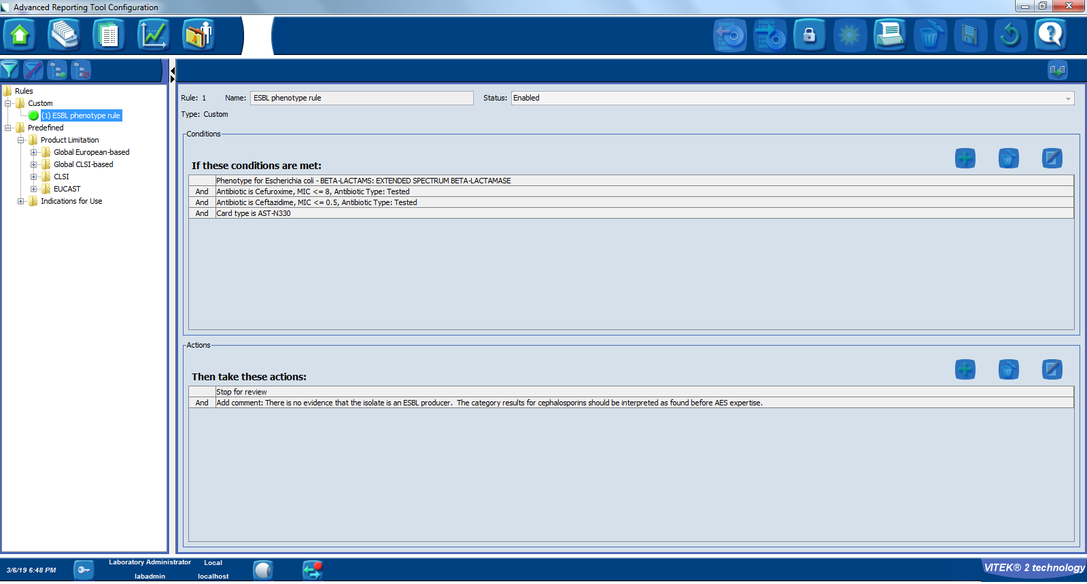
Figure 1: Completed bioART rule (example for AST-N330)

Detailed steps to create a custom bioART rule

Create a new custom bioART Rule

- Login to the VITEK 2 Systems application as a member of the Supervisors group.

- From the main view, click on the configuration icon and select Advanced Reporting Tool option.
- Click the unlock/lock icon.

- Click ”Yes” on the informational pop-up message.
- Click on the Create New Rule icon.

- Enter a name for the rule.

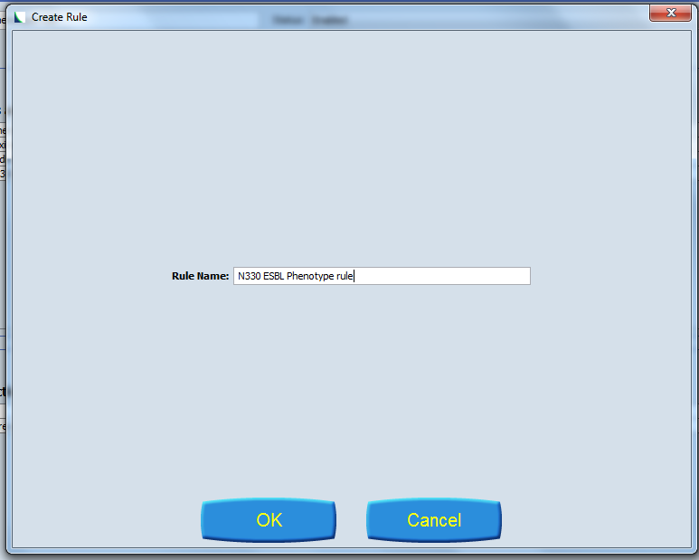
Figure 2: Rule name creation (example for AST-N330)

- Click OK.

Adding conditions to the rule

You will add a total of 4 conditions to the rule. They include: Phenotype, Antibiotic/MIC cefuroxime, Antibiotic/MIC ceftazidime, and AST card class. Follow these steps.

- Click on the Plus sign to add a condition.

- Create the first condition by choosing Phenotype
  - Next select BETA-LACTAMS and choose the following:
    - Organism: Escherichia coli
    - Phenotype: EXTENDED SPECTRUM BETA-LACTAMASE
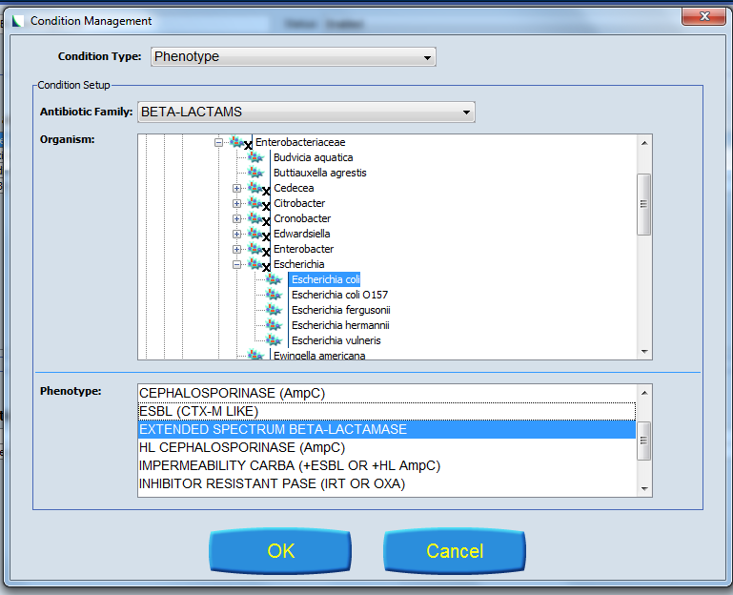

Figure 3: Selecting phenotype condition

3. Add a second condition by clicking on the “Add a Condition Button”.
- Select Antibiotic/MIC
- Choose antibiotic: Cefuroxime
  - Leave “Use any Antibiotic Version” box checked
- Select MIC, <= , and input 8 for the value
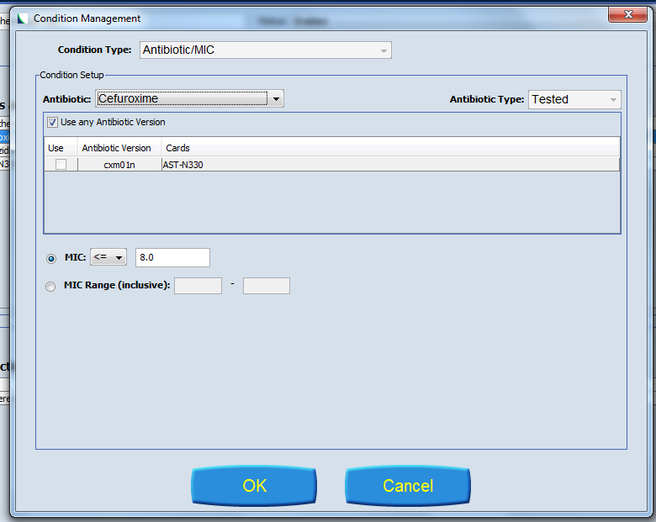

Figure 4: Selecting Cefuroxime condition

4. Add a third condition by clicking on the “Add a Condition Button”
- Select Antibiotic/MIC
- Choose antibiotic: Ceftazidime
  - Leave “Use any Antibiotic Version” box checked
- Select MIC, <= , and input 0.5 for the value

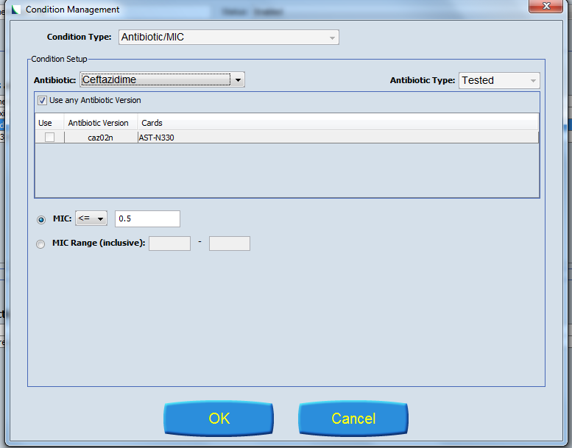

Figure 5: Selecting Ceftazidime condition

6. Add a fourth condition by clicking on the “Add a Condition Button”
- Select Card type; NXXX (where XXX is the card type designation, 254 / 330 / 371)

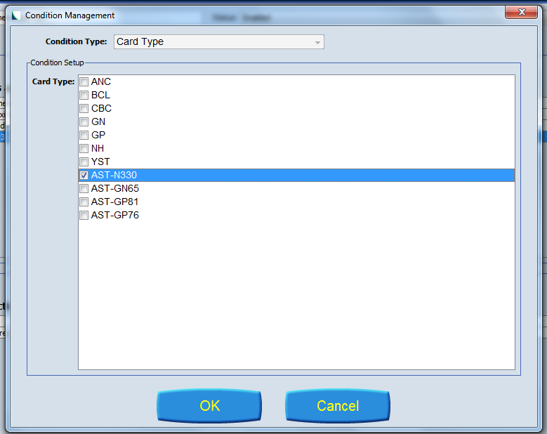

Figure 6: Selecting card type condition (example for AST-N330)

The condition part of the rule is now complete. The next step is to add the “Stop for Review” and “Internal Comment” actions.

Adding an action to the rule

You will add a total of 2 actions to the rule. They are “Stop for Review" and “Internal Comment". Follow these steps.

- Click on the Plus sign to add an action.
- Choose the following actions:

  - Stop for Review
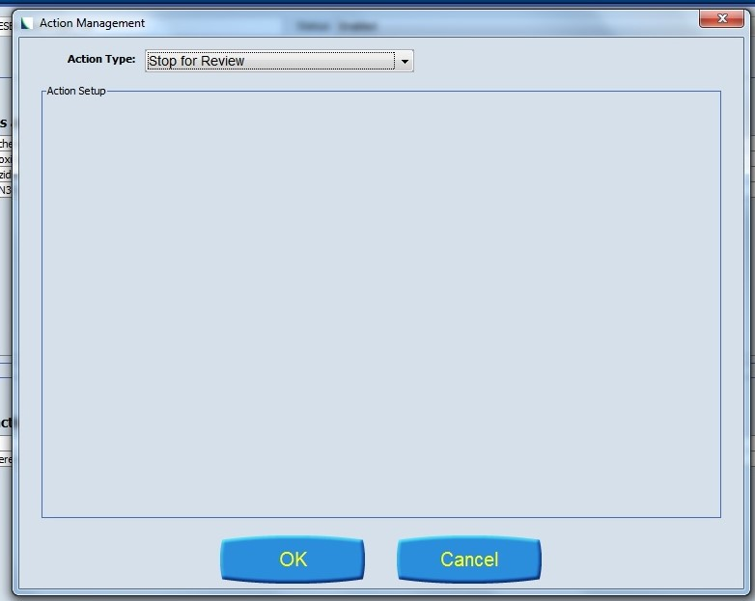

Figure 7: Selecting Stop for Review action

  - Add Internal Comment
    - Enter the following comment: “There is no evidence that the isolate is an ESBL producer. The category results for cephalosporins should be interpreted as tested, before AES expertise.”

Figure 8: Selecting and adding Internal Comment action

- Press Save.

The rule is now complete. Four conditions and two actions have been created. Review the rule. It should look similar to the following:

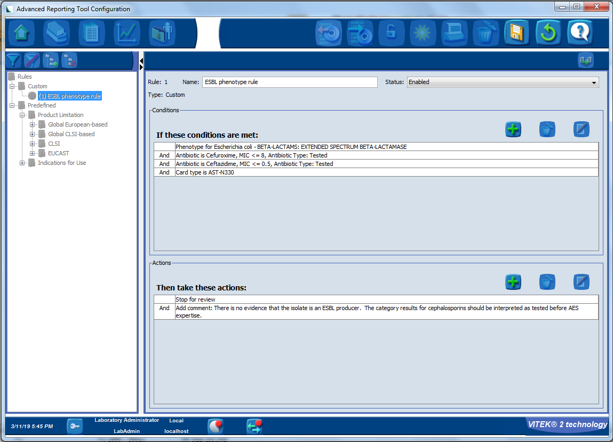

Figure 9: Completed bioART rule (example for AST-N330)

Final steps:
- Press the lock/unlock button to end customization mode.
- Navigate back to the main view.
- Close the VITEK 2 Systems application.

If you have any questions regarding these steps, please contact your local bioMerieux support representative.

