Date: 29/08/2022
Intersurgical Ltd.

Urgent Field Safety Notice
Solus Standard, laryngeal mask airway, size 3

For Attention of*:All clinical staff, managers and users of the above product

Contact details of local representative (name, e-mail, telephone, address etc.)*
This could be a distributor or local branch of the manufacturer. To be added at the appropriate stage in the different local languages

Urgent Field Safety Notice (FSN)
Intersurgical Ltd.

Solus Standard, laryngeal mask airway, size 3
Risk addressed by FSN

- Information on Affected Devices*
1. | - Device Type(s)*
 | Solus Standard, laryngeal mask airway, size 3, small adult, 30-50kg
1. | - Commercial name(s)
 | Solus Standard, laryngeal mask airway, size 3, small adult, 30-50kg
1. | - Unique Device Identifier(s) (UDI-DI)
 | N/A
1. | - Primary clinical purpose of device(s)*
 | Securing and maintaining a patent airway. To provide a conduit for the delivery of respiratory gases to the patient.
1. | - Device Model/Catalogue/part number(s)*
 | 8003000
1. | - Software version
 | N/A
1. | - Affected serial or lot number range
 | 32204071
1. | - Associated devices
 | N/A

- Reason for Field Safety Corrective Action (FSCA)*
2. | - Description of the product problem*
As a result of a printing error on the device, size 3 Solus Standard laryngeal mask airway has been incorrectly marked with size 4 information. This includes the number ‘4’ as a size identifier, patient weight and maximum inflation volume on the airway tube and the marking #4 on the inflation line pilot balloon.

The size 3 laryngeal mask airway is supplied with the correct reference code and description on the device packaging.

However, the wrong size product could still be selected for use if the size required is selected solely on the basis of the markings on the device.

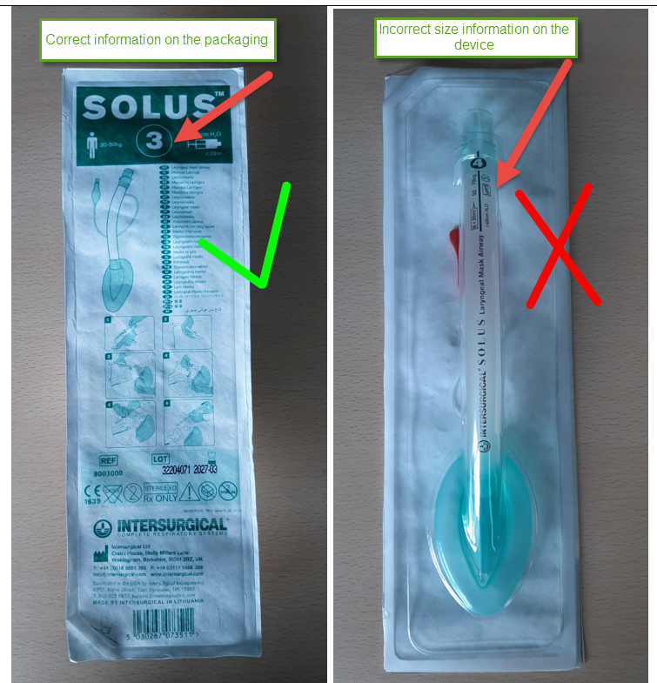

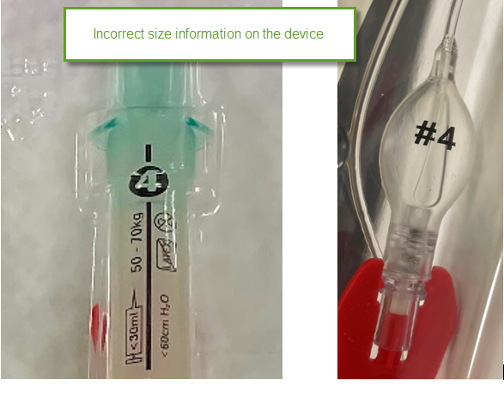

2. | - Hazard giving rise to the FSCA*
The following potential hazards exist as a result of the printing error:

- If a laryngeal mask is smaller than appropriate for the patient, it may not be possible to position the device correctly, create a seal, or create a seal within the specified maximum inflation parameters. The device may be inserted too deeply causing trauma and obstruction.

- Using a device too small for the patient may also increase the risk of device instability intraoperatively leading to the loss of a secure airway with all the associated risks.

- It may not be possible to ventilate the patient adequately and without a secure airway with an appropriate seal, there may be an increased risk of aspiration if regurgitation were to occur. Without adequate oxygenation the patient may become hypoxic.

- As the maximum inflation volume on the device is also incorrect (it states <30ml rather than < 20ml) there is an increased risk of over-inflation causing patient trauma. In addition, over-inflation could lead to the cuff being stretched, deforming or bursting. This could lead to a loss of seal, trauma, or loss of a secure airway.

- Any increase in the number of insertion attempts or manipulations to try and position the device correctly is likely to increase the risk of airway complications and can lead to a (more) difficult airway being created, complicating the patient outcome.

- There may be a delay to treatment.

2. | - Probability of problem arising
 | Probability of problem arising in the indicated lot is up to 100%.
2. | - Predicted risk to patient/users
 | There is a potential for life threatening incidents.
2. | - Further information to help characterise the problem
2. | - Background on Issue
 | Printing error
2. | - Other information relevant to FSCA
 | This field may only contain additional information that is deemed necessary by the manufacturer to supplement information relevant to the FSCA.

 | - Type of Action to mitigate the risk*
3. | - Action To Be Taken by the User*  ☐ Identify Device ☒ Quarantine Device ☐ Return Device ☒ Destroy Device  ☐ On-site device modification/inspection  ☐ Follow patient management recommendations  ☐ Take note of amendment/reinforcement of Instructions For Use (IFU)  ☐ Other ☐ None  Identify any potentially affected devices as indicated in this Field Safety Notice, and immediately Quarantine them. Please destroy any affected devices and complete the enclosed Customer Reply Form and return it to the contact at the top of the Response Form. Request a credit to be arranged from the local distributor as required. Please continue to report any adverse events involving this product to Intersurgical.
3. | - By when should the action be completed? | Immediately on receipt of this FSN
3. | - Particular considerations for: Choose an item.  Is follow-up of patients or review of patients’ previous results recommended?  No  Not applicable
3. | - Is customer Reply Required? *  (If yes, form attached specifying deadline for return) |  | Yes
3. | - Action Being Taken by the Manufacturer  ☒ Product Removal ☐ On-site device modification/inspection  ☐ Software upgrade ☐ IFU or labelling change  ☐ Other ☐ None  Return all affected products to the local distributor, credit will be arranged as required.
3 | - By when should the action be completed? | Specify where critical to patient/end user safety
3. | - Is the FSN required to be communicated to the patient /lay user? |  | No
3 | - If yes, has manufacturer provided additional information suitable for the patient/lay user in a patient/lay or non-professional user information letter/sheet?
 | Choose an item. Choose an item.

 | - General Information*
4. | - FSN Type* | New
4. | - For updated FSN, reference number and date of previous FSN | Provide reference and date of previous FSN if relevant
4. | - For Updated FSN, key new information as follows:
 | Summarise any key difference in devices affected and/or action to be taken.
4. | - Further advice or information already expected in follow-up FSN? * | No
4 | - If follow-up FSN expected, what is the further advice expected to relate to:
 | Eg patient management, device modifications etc
4 | - Anticipated timescale for follow-up FSN | For provision of updated advice.
4. | - Manufacturer information  (For contact details of local representative refer to page 1 of this FSN)
 | - Company Name | Intersurgical Ltd.
 | - Address | Crane House, Molly Millars Lane, Wokingham, Berkshire, RG41 2RZ
 | - Website address | https://www.intersurgical.com/
4. | - The Competent (Regulatory) Authority of your country has been informed about this communication to customers. *
4. | - List of attachments/appendices: | Customer Reply Form
4. | - Name/Signature | Ivan Seniut, Group Quality and Regulatory Affairs Director, Intersurgical
 | Transmission of this Field Safety Notice
This notice needs to be passed on all those who need to be aware within your organisation or to any organisation where the potentially affected devices have been transferred. (As appropriate)

Please transfer this notice to other organisations on which this action has an impact. (As appropriate)

Please maintain awareness on this notice and resulting action for an appropriate period to ensure effectiveness of the corrective action.

Please report all device-related incidents to the manufacturer, distributor or local representative, and the national Competent Authority if appropriate, as this provides important feedback..*

Note: Fields indicated by * are considered necessary for all FSNs. Others are optional.

