***Urgent Field Safety Notice for:***

***Dako Autostainer Instruments (AS480; AS100; S3800; S3400):***

**«Account_Name»**

**«Owner account no.»**

**«Address1»**

**«City», «Postal_Code»**

**«State», «Ctry»**

Location, Date

**Update of Autostainer Link Basic User Guide to reduce risks of staining issues due to leakage**

Dear Valued Customer,

We are writing to inform you of updated instructions to our Autostainer Link Basic User Guide (rev. 06) to reduce the potential risk of false negative results in the case of leakage of buffer and/or reagents that may impact staining. The Autostainer Link Basic User Guide (rev. 06) provides instructions on the appropriate inspections and cleaning of the instrument to improve detection of possible leakage and potential staining abnormalities.

There is a reasonable probability that a staining anomaly could occur due to Autostainer leakage and this may in turn lead to a false negative result. Therefore, it is important to follow the updated manual for the detection of leaks.

The updated version of the Autostainer Link Basic User Guide (rev. 06), contains additional instructions, warnings and precautions that applies to all Autostainer instrument models (AS480, AS100, S3800 and S3400). We have identified these changes below.

In addition to this revision to the User Guide, we would like to remind you to run controls on all slides, as recommended under the “Drop Zone and Volume Considerations” on page 17 of the English version, to improve patient safety.

**Revised instructions in the Autostainer Link Basic User Guide:**

Autostainer Link Basic User Guide has been updated regarding the following:

* **It is specified that an instrument malfunction could be a leakage** (Section “Disclaimer”, start of section in English version: page 2)
* **Rephrased the considerations concerning placement of slide labels from recommendation to necessary action** (Subsection “Slide Label Considerations”, start of subsection in English version: page 18)
* **New section below added on inspection procedure of the instrument in case of suspected leakage including a new warning-box** (Subsection “Leakage Inspection”, start of subsection in English version: page 18)

**“Leakage Inspection:**

Be aware of leakage from the robotic arm or z-head as staining quality may be impacted. Leakage may directly impact reagent incubation as drops of buffer can fall onto the slides during the run. Leakage may affect the aspiration and dispensing accuracy which has the potential to impact staining quality as well. For best results, these guidelines to identify leakage from the liquid system must be followed:

After each run visually inspect the syringe tray, syringe, stopcock, the left plate, and the area around the wash station for evidence of unexpected leakage (salt residues and/or liquid), see section 17 - Cleaning and Maintenance for details.

If there are signs of unexpected leakage (salt residues and/or liquid), contact your local Technical Service representative immediately as this might indicate a leakage in the system.

If leakage is observed, the slides from the last run must be closely reviewed for staining abnormalities.

Do not use the instrument if there are signs of unexpected leakage. Call your local Technical Service representative.

* **Clarification of action to clean and inspect the Syringe Tray, Syringe and Stopcock set forth below** Table in “Cleaning and Maintenance Guideline Summary”, in English version: page 182, and in subsection “Syringe tray, syringe and stopcock inspection”, start of subsection in English version: page 188)

**“syringe tray, syringe and stopcock inspection:**

Inspection Interval: after each run, every month, and every three months.

Visually Inspect the syringe tray, syringe and stopcock for salt residues and/or liquid, see picture below. If there are signs of unexpected salt residues and/or liquid, contact your local Agilent Technical Service representative as this might indicate a leakage in the system.

Wipe the syringe tray with a sponge or a soft cloth soaked with DI water or mild detergent to remove dust and potential salt crystals. Do not use abrasive cleansers.”

* **New section below has been added regarding inspecting the instrument for signs of leakage** (Table in “Cleaning and Maintenance Guideline Summary”, in English version: page 182, and in subsection “Instrument Leakage Inspection”, start of subsection in English version: page 188)

**“Instrument leakage inspection**

Inspection Interval: after each run, every month, and every three months.

Visually Inspect the left plate, and the area around the wash station for salt residues and/or liquid, see pictures below. If there are signs of unexpected salt residues and/or liquid, contact your local Agilent Technical Service representative as this might indicate a leakage in the liquid system. If leakage is observed, the slides from the run just completed must be closely reviewed for staining abnormalities.”

|  |
| --- |
| ***WARNING***   *Leakage from the robotic arm or z-head may impact staining quality. Do not use the instrument if there are signs of unexpected leakage (salt residues and/or liquid), or if you observe leakage.*  *Immediately contact your local Technical Service representative.* |

|  |
| --- |
|  |
| Visually inspect the syringe tray, syringe and stopcock, areas highlighted in red, for signs of unexpected leakage (salt residues and/or liquid). |

|  |  |
| --- | --- |
|  |  |
| Visually inspect the left plate, area highlighted in red, for signs of unexpected leakage (salt residues and/or liquid). This might indicate leakage from the robotic arm. | Visually inspect the area around the wash station, area highlighted in red, for signs of unexpected leakage (salt residues and/or liquid). This might indicate leakage from the z-head or too high pump pressure. |

* **Revision to Cleaning and Maintenance Guide Summary requiring that inside-instrument cleaning is to be performed after each run and during the monthly and quarterly cleaning** (“Inside Instrument cleaning” section, start of section in English version: in page 188)

**Cleaning and Maintenance Guideline Revised Summary**

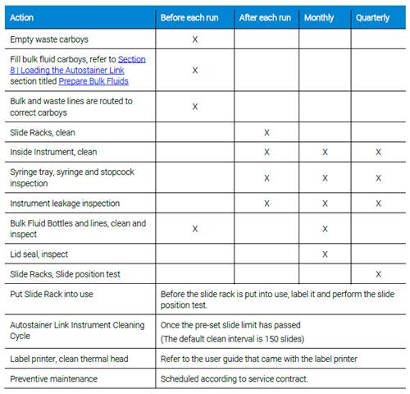

* **For all of these activities, your Agilent representative should be contacted immediately for assistance in the event of any instrument malfunction, including leakage.**

**Actions to be taken by the user:**

Please take the following actions:

1. Carefully read and communicate to those within your organization of the updates stated in this notification letter and attached Autostainer Link Basic User Guide (rev. 06). Your local sales team will confirm with you that you have read and acknowledged this notification.
2. Your Agilent representative should be contacted immediately for assistance in the event of leakage.
3. Please discard previous versions of the Autostainer Link Basic User Guide that you are currently using.

Please contact your local sales representative or call if you have any questions regarding this notification, or if you would like any further assistance. The link below provides regional support contacts.

<https://www.agilent.com/en/support/agilent-pathology-support-contacts>

Additionally, adverse reactions or quality problems experienced with the use of this product may need to be reported to the National Competent Authority.

**Reporting to authorities (only applicable for EEA countries):**

Please be aware that the relevant National Competent Authorities have been advised of this safety notice.

**Transmission of this notice:**

Thank you for your attention to this matter. We apologize for any inconvenience that this action may cause, and we appreciate your understanding as we take actions to ensure patient safety and customer satisfaction.

We value your confidence in our solutions which help patients, hospitals and diagnostic laboratories around the world in the relentless fight against cancer.

Sincerely,

Asger Dahlgaard

QA Operation and Vigilance Director

Pathology Division, Quality/Regulatory

dako.dkvigilance@agilent.com

Signature:

