January XX, 2024

Advisory Notice / Preventive security information

**RE: FUJIFILM MOBILE DIGITAL X-RAY SYSTEM FDR nano**

Dear Sir or Madam:

We would like to inform you that FUJIFILM has recently been alerted to examinations carried out in pediatric, neonatal and maternity departments with default exposure values that are intended for adult chest imaging and could lead to a risk of overexposure.

There have been no reported patient injuries associated with this issue. After a non-compliant turn-off, we believe that this issue could happen due to insufficient description in our operation manual.

Therefore, we are providing additional information in this letter.

We recommend carrying out a retrospective analysis of dosimetric data, particularly in pediatrics, neonatology and maternity departments, in order to identify patients who could potentially be affected by overexposure.

FUJIFILM appreciates your understanding and cooperation. Please keep a copy of this letter with our operation manual. If you have any questions regarding this letter or if you would like to schedule additional training/in-service, please contact <<local contact name >>, via <<local contact email >> and md-safetyofficer@fujifilm.com.

Sincerely,

<<sign>>

<< Dealer Details >

**FUJIFILM MOBILE DIGITAL X-RAY SYSTEM FDR nano / Additional Information**

**Warning**

* Whenever the key switch is turned on, the exposure conditions are set to the default values (85 kV, 1.6 mAs, approx. 0.13mGy@ SID 1m) which are intended for adult chest imaging. Before making an exposure, make sure that intended exposure conditions are set.
* Failure to follow the above warning may result in overexposure in comparison with the selected study, especially for children.
*  If exposure conditions are set from the console while the key switch is off, the set exposure conditions will not be reflected.

Turning on the key switch

When the key switch is turned on, the exposure condition panel lights up.

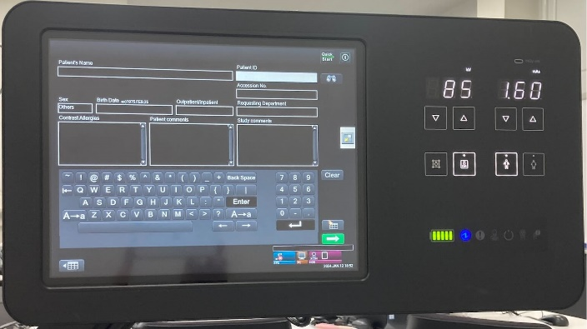

**Steps to Re-set Exposure Conditions**



Study screen

1. **Closing the Study screen**

Exiting the Study screen and Starting over a study.  
Press [Complete] to exit the Study screen.

1. **Re-setting a study**

**2.1 When connected to RIS**

Start over from selecting a Study   
(See Section 4.1.2 of “Console Advance (DR-ID 300CL) Operation Manual”.)

**2.2 Other than RIS connection**

Start over from selecting Exposure Menu   
(See Section 4.2.1 of “Console Advance (DR-ID 300CL) Operation Manual”.)

1. **Exposure**

Before making an exposure, make sure that intended exposure conditions are set.

Note: For other operational procedures, please refer to “FDR nano Operation Manual”.

End of File