URGENT - FIELD SAFETY NOTICE
MAQUET VOLISTA
Field Action MSA/2017/006/IU
Date: | <month> <day>,<year>
Product Issue: | Detachment of the central handle holder from the VOLISTA surgical light
Affected Product: | 5214 MAQUET VOLISTA StanOP, Triop and Access cupolas. All potentially affected devices in your market are listed in the attached list of products.
Resolution: | Maquet proposes to replace the central holder ring of your VOLISTA surgical light to make sure all devices present in the market are working effectively and safely.
Affected Serial Nos.: | All potentially affected devices in your market are listed in the attached list of products.
Field Safety Notice: | MSA/2017/006/IU
Pages: | 4

Dear Customer,

Our records indicate that you bought one or more VOLISTA surgical lights manufactured before July 2016.

This letter is to inform you of a corrective action that will be performed on these units to prevent a possible hazard to persons and equipment. This action consists in a the replacement of the central handle holder ring.

We received complaints indicating that the central handle holder detaches easily from the cupola during use. We determined that the root cause of this malfunction is excessive tightening of the screws during mounting of the handle holder, resulting in the rivets loosening and detaching from the central handle holder ring.

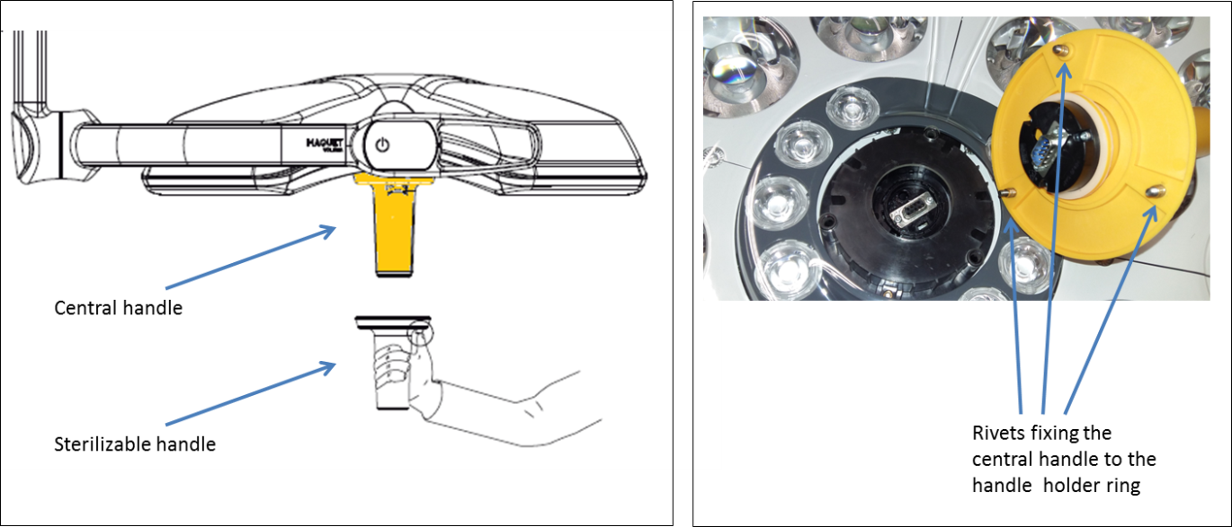

During manipulation, the handle holder may completely detach from the light head, if all three rivets loosen simultaneously. In this case, although the handle remains in the user’s hand, small quantities of particles may be generated from the plastic holder ring. From our clinical evaluation, it was concluded that there is a remote chance that this issue may cause post-operative infection, foreign body granuloma or allergic reactions, if the particles fall into the patient’s wound or on sterile equipment.

The issue was solved in production by a design change of the rivets (modification of shape and overmolding with the handle holder ring). For units manufactured before application of the modification in production, we see the issue as a potential long term hazard and want to prevent any related event from occurring with our customers. This action consists in the replacement of the existing central holder rings with the new design.

Next Steps

- Please make sure that all users of the VOLISTA surgical lights are made aware of this Field Notice and all listed devices at your facility are accessible during the MAQUET service technician visit.

- Complete and sign the enclosed Customer Response Form and return this form to the local MAQUET office.
Note: A MAQUET Sales or Service person will contact the person you listed on the Customer Response Form to schedule service to replace your device, free of charge.

Transmission of this Field Notice:

This MAQUET VOLISTA Field Notice needs to be distributed to those individuals who need to be aware within your organization - or to any organization where the potentially affected devices have been transferred.

Please maintain awareness of this notice and resulting action for the use period of the device to ensure effectiveness of the corrective action.

In cases where you as customer choose not to proceed with completion of the corrective action requirements described above, MAQUET cannot accept any responsibility for safety related issues or legal liabilities caused by the failure to respond to this Field Safety Notice.

Additional Comment

We deeply regret this inconvenience, but we greatly appreciate your understanding as we take actions to ensure correct product performance. If you have any further questions or require assistance completing the Customer Response Form, please contact MAQUET.

Françoise GAUDUCHON
Quality Manager, Surgical Workflows
Maquet SAS
Parc de Limère, Avenue de la Pomme de Pin
CS 10008 Ardon, 45074 Orléans cedex 2
France

Customer Response Form
MSA-2017-006-IU

Reference: Urgent Field Safety Notice, MAQUET VOLISTA surgical light

Our records indicate that the VOLISTA surgical light shown below was delivered to your location. Please verify if you have any of the listed devices that are potentially affected and complete the information below.
GETINGE ORDER NO. | ITEM NO. | SERIAL NO. | MANUFACTURING DATE
 | -
Record the total number of affected device currently located at your facility here please ___.

Please check the appropriate boxes below:

We have read the VOLISTA Field Safety Notice and we understand the communication and the required actions.
If checked : please provide information where the affected devices are physically located.
Field Safety Notice Receipt and Customer Response Form Completion and Certification

Current Facility Name
Contact Name / Title
Address (no PO boxes, please)
City, State, Zip
Phone Number |  | Fax:
E-Mail Address:

We have sold/moved our VOLISTA surgical light to another facility.
If checked : please provide new facility information below.
New Facility Name
Contact Name / Title
Address*
City, State, Zip
Phone Number |  | Fax:
E-Mail Address:

PLEASE RETURN YOUR COMPLETED FORM TO:
MAIL CONTACT
<local SSU address line 1> <contact address>@getinge.com
<local SSU address line 2> Tel: <SSU contact phone number>
<local SSU address line 3> Fax: <SSU contact fax number>
<local SSU address line 4>

