URGENT DEVICE CORRECTION

March DD, 2017 (to be adapted locally)

Dear Healthcare Provider: (to be adapted locally),

Problem Description | Baxter Healthcare Corporation (to be adapted locally) is initiating a field action in order to update software versions of the Prismaflex Control Unit. Baxter has received reports of device operators failing to adhere to the instructions for use pertaining to the safe unloading of disposable sets from the Prismaflex Control Unit. These steps are required to safely disconnect the patient before proceeding to unload the filter set after treatment. If not followed, severe blood loss may occur with a potentially fatal outcome.
Affected Product  (to be adapted locally) | Product Code Product Description Serial Number  107493 Prismaflex System All  113082 Prismaflex 4.11 All  113874 Prismaflex 5.00 Row All  114489 Prismaflex 6.10 Row All  114870 Prismaflex 7.XX Row All  955052 Prismaflex 8.XX Row All  6023014700 Prismaflex All
Hazard Involved | Unloading of the disposable set without following the instructions and warnings on the Prismaflex Control Units may lead to severe blood loss and potentially fatal outcomes.  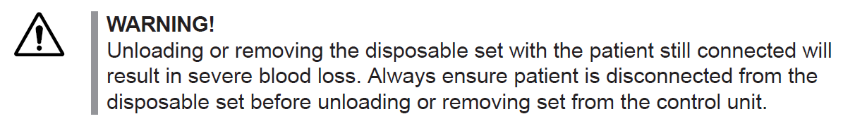  Since 2012, Baxter has received reports of six serious injuries and five patient deaths associated with this issue.
Actions taken by Baxter to avoid reoccurrence of the issue | Through this letter, Baxter is kindly reminding its customers that Prismaflex is designed with specific features to ensure that device operators safely disconnect the patient before proceeding to unload the filter set after treatment. Specific instructions provided in the Operator’s manual and displayed on-screen require that, before proceeding with unloading the filter set, the operator must:  - Clamp all lines,  - Disconnect Access and Return blood line from the blood access device, and  - Verify that all lines are clamped and the patient is disconnected  In addition, Baxter will be releasing an updated software version that will take additional measures to further ensure patient safety. An additional automated test will ensure the operator has clamped the Access and Return blood line. If lines are found not to be clamped, the unload sequence will be stopped and the operator will be notified with a device alarm.
Information and Instructions for the Users and Distributors | - Operators may continue to safely use the affected units by following the instructions provided in the Prismaflex Operator’s Manual and the on-screen instructions when unloading the disposable set. Specifically, operators should ensure that all lines are clamped and the patient is disconnected before proceeding with unloading.  - A local Baxter service representative will contact your facility to determine the correction plan and schedule the software upgrade. Your facility will be receiving this software upgrade from Baxter at no charge.  - Complete the enclosed customer reply form, and return it to Baxter by either faxing it to (insert local contact information) or scanning and e-mailing it to (insert local contact information) or sending it by post to (insert local contact information). Returning the customer reply form promptly will confirm your receipt of this notification and prevent you from receiving repeat notices.  - Please forward a copy of this letter as appropriate to ensure that all users are aware of this communication.  - If you are a dealer, wholesaler, or distributor/reseller distributing this product to other facilities, please notify your customers of this communication in accordance with your procedures.
Further information and support (to be adapted locally) | For general questions regarding this communication, contact Baxter at (insert local contact information), between the hours of (insert local information).
We apologize for any inconvenience this may cause you and your staff. Baxter’s software version update will take additional measures to further ensure patient safety. Baxter is committed to ensuring our products and services consistently meet the highest standards of quality and safety for our patients and healthcare providers.

The Local MOH (to be adapted locally) has been informed about this action. (To be removed if not applicable)

Sincerely,
Name (to be adapted locally)
Title (to be adapted locally)
Medical Products (to be adapted locally)
Baxter Healthcare Corporation (to be adapted locally)

Attachment: Customer Reply Form

Attachment: Customer Reply Form

Urgent DEVICE CORRECTION LETTER dated XX (to be completed locally)
Product Family: Prismaflex
Product names: Prismaflex System, Prismaflex 4.11, Prismaflex 5.00 Row, Prismaflex 6.10 Row, Prismaflex 7.XX Row, Prismaflex 8.XX Row, Prismaflex (To be adapted locally)
Product codes: 107493, 113082, 113874, 114489, 114870, 955052, 6023014700 (To be adapted locally)
Please complete and return one copy of this form per facility either by fax (____________) or by e-mail (__________________) as confirmation that you have received this notification. A fax cover sheet is not required. (Can be adapted locally)
Customer Confirmation
We confirm that that we have have received the above mentioned letter, understood its content and have disseminated this information to our staff, other services and facilities.
We confirm that we have received the above mentioned letter, understood its content and have disseminated this information to our Customers (To be adapted locally - for Distributor)
Facility Name and Address:
(Please Print)
Product code and Serial Number of
Machine
Reply Confirmation Completed By:
(Please Print Name)
Title:
(Please Print)
Email and/or Telephone Number
(Including Area Code):
Signature/Date:  REQUIRED FIELD | _________________________________/____/_____

