[XX] July [XX] 2017 [Reference: QIL-150P-02]

[URGENT: FIELD SAFETY NOTICE / FIELD SAFETY CORRECTIVE ACTION]
[URGENT: RECALL - MEDICAL DEVICE CORRECTIVE ACTION]

Attention: Operating Room Manager

Regarding: Cystoscopy Bridges and Working Inserts - detaching fragments of adhesive

Model Number | Model Description | Lot Number(s)
A20975A | Working insert, with ramp, one way | [to be populated]
A20976A | Bridge, one way | [to be populated]
A20977A | Bridge, two way | [to be populated]

[Dear Customer,/:]
[Dear Healthcare Provider,/:]
[Dear Healthcare Practitioner,/:]

OLYMPUS is implementing a [Field Safety Corrective Action ("FSCA") / medical device corrective action] of the cystoscopy bridges and the working insert referenced above. Cystoscopy bridges and working inserts are used for endoscopic diagnosis and treatment in urologic applications.

OLYMPUS has initiated this [FSCA / medical device corrective action] after receiving complaints about fragments of adhesive which detached from inside the working channel of the referenced cystoscopy bridge models. Cracking, chipping, missing pieces, and delamination of the adhesive have been observed. Investigations have confirmed that this adhesive can detach during the intended use of the cystoscopy bridge or working insert, e.g. when inserting an instrument through the working channel. As a result, a fragment of the adhesive may fall inside the patient's bladder or urethra and will need to be retrieved. Although typically flushed out with irrigation fluid or passed naturally, the retrieval of large fragments of the adhesive could require additional surgical treatment. Furthermore, the procedure can be prolonged resulting in extended anesthesia.

There has been no report about an adverse event or patient injury related to this issue. However, in an effort to prevent a potential risk to patient health, OLYMPUS is launching this action to provide its customers cystoscopy bridges and working inserts without adhesive. To achieve this, OLYMPUS will either rework the devices to remove the adhesive from the working channel or replace the devices completely. Please note that the lack of adhesive does not affect instrument passage.

Investigation results confirmed that these devices are safe to use until being reworked or replaced.

Action steps to be taken by the end user:
Our records indicate that your facility has purchased one or more of the affected cystoscopy bridge and/or working insert models with the lot numbers listed above. OLYMPUS requires you to take the following actions:

- Inspect your inventory for the referenced devices and identify any of the specified model and lot numbers identified above. The model and lot number can be found on the device as illustrated in the following pictures.

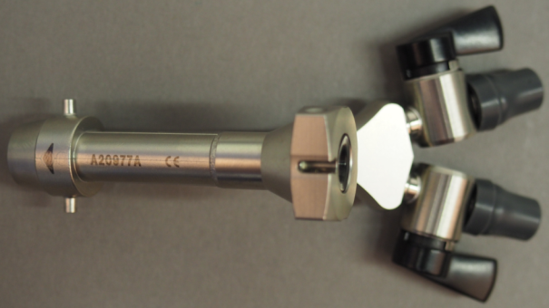
Picture 1: model number on the cystoscopy bridge

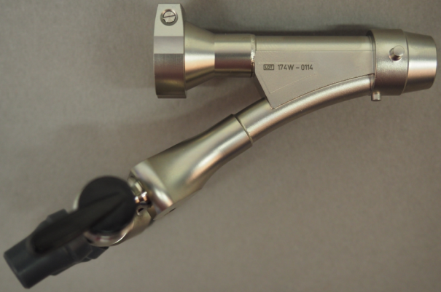
Picture 2: lot (LOT) number on the cystoscopy bridge

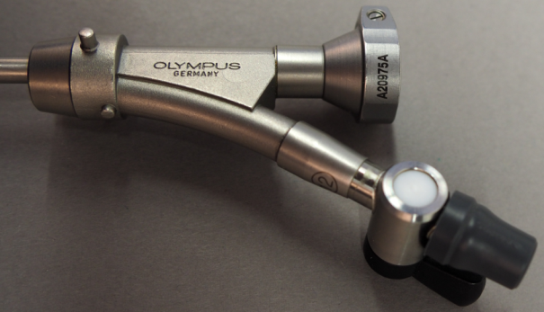
Picture 3: model number on the working insert

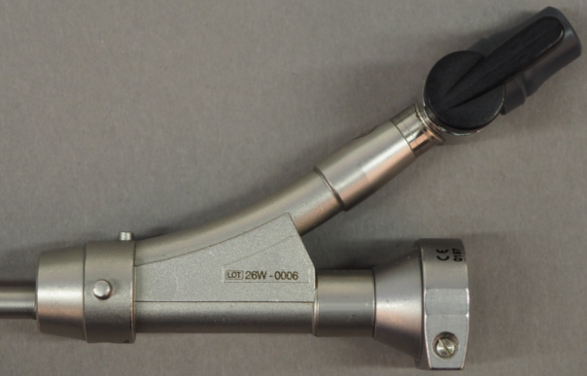
Picture 4: lot (LOT) number on the working insert

- Contact [the OLYMPUS Customer Care Center / the OLYMPUS Helpdesk / the OLYMPUS Service Center / your local OLYMPUS representative] at [telephone number] to schedule the successive return of all your affected devices for rework/replacement [and to arrange for temporary loan units if applicable].
- Please note on the enclosed reply form that you have received this [Field Safety Notice ("FSN") / medical device corrective action notice] and include the quantity of any affected devices you have identified in your inventory and intend to return.
- Fax or e-mail the completed reply form to [Department] at [telefax number] or [e-mail address].
The [local / national Competent Authority] is aware of this action.

OLYMPUS regrets any inconvenience this action may have caused and fully appreciates your prompt cooperation. If you have any questions or concerns, please do not hesitate to contact me directly at [telephone number] or at [e-mail address].

Sincerely,

[Name]
[Position]
[Department]
[S-BC / Distributor]

