January XX, 2017

URGENT SAFETY NOTIFICATION
IMPORTANT UPDATED LABELING INFORMATION:
NEW REPROCESSING INSTRUCTIONS FOR THE OLYMPUS TJF-145 DUODENOSCOPE

ATTENTION: Endoscopy Department, Risk Management and Reprocessing Units

Dear Health Care Professional:

Olympus XX is writing to inform you that we are issuing validated, new reprocessing instructions for the Olympus TJF-145 duodenoscope, consisting of revised manual cleaning and disinfection procedures to increase the safety margin against infection after ERCP using the TJF-145.

These new reprocessing procedures should be implemented as soon as possible. The new cleaning procedure requires the use of a new cleaning brush (MAJ-1534), which is enclosed with this letter.

After the enclosed brushes are consumed, the brushes will be available for purchase in sufficient quantities to meet your facility’s needs through our normal sales order process. Please note the MAJ-1534 brush is a reusable brush, which can be sterilized by autoclave following use. Instructions for sterilizing the MAJ-1534 brush can be found in the enclosed, new Reprocessing Manual.

In addition to the new cleaning brush referenced above, the new TJF-145 reprocessing procedures require additional flushing and forceps elevator raising/lowering steps during precleaning and manual cleaning, manual disinfection, endoscope rinsing and alcohol flushing. The new Reprocessing Manual is enclosed with this letter.

Please note the key differences in the new reprocessing procedure:

Precleaning:

- Flush the elevator wire channel with water

Manual Cleaning:

- Additional brushing of the forceps elevator recess area and the elevator wire
- The revised cleaning procedure requires brushing of the forceps elevator recess. In addition to the brushes that are currently used to clean the elevator recess area, the MAJ-1534 brush is required for further cleaning of this area. Enclosed with this letter is a quantity of MAJ-1534 brushes.
- The revised brushing steps of the TJF-145 and brush models required for each steps are as follows. Please follow the detailed steps instructed in new reprocessing instructions for TJF-145.
Step | Brushing Point | Brush models to be used
1 | ・Forceps elevator  ・Forceps elevator recess  ・Instrument channel outlet | Channel-opening cleaning brush  (MH-507)
2 | ・Forceps elevator  ・Forceps elevator recess | Channel cleaning brush  (BW-20T)
3 | ・Distal end of the endoscope except the forceps elevator and the forceps elevator recess | Channel-opening cleaning brush  (MH-507)
4 | ・Instrument channel  ・Suction channel | Channel cleaning brush  (BW-20T)
5 | ・Suction cylinder  ・Instrument channel port | Channel-opening cleaning brush  (MH-507)
(Aspirate detergent solution through the instrument channel and the suction channel)
6 | ・Forceps elevator  ・Forceps elevator recess  ・Elevator wire | The cleaning brush (MAJ-1534)

- Additional flushing of forceps elevator recess area and the elevator wire

- Additional raising/lowering the forceps elevator

Manual Disinfection:

- Additional manual flushing steps and increased flushing volume of each endoscope channel, as well as the elevator recess area

- Additional raising/lowering of the forceps elevator

The new Reprocessing Manual is distinguished from the prior Reprocessing Manual versions as illustrated in the image below. The new cleaning brush, MAJ-1534, is described on the cover of the new TJF-145 Reprocessing Manual. The new Reprocessing Manual has version number RCXXXX YY on the back cover, lower left corner.

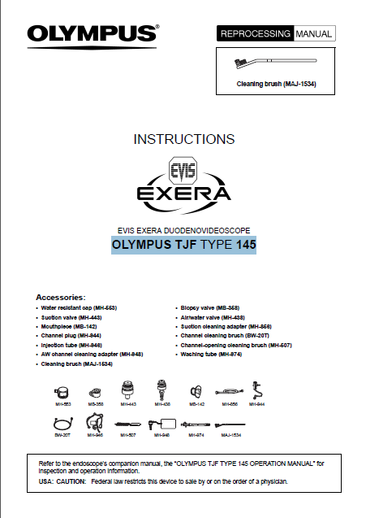

Action Steps:
Our records indicate your facility has purchased a TJF-145 duodenoscope. Olympus 145 requires you to take the following immediate action:

- Olympus has discontinued previously distributed copies of the TJF-145 Reprocessing Manual. Inspect your inventory of Reprocessing Manuals and discard any existing inventory of TJF-145 Reprocessing Manuals.
- Implement use of the enclosed TJF-145 Reprocessing Manual, which contains new brushing and flushing steps for the TJF-145's elevator mechanism and the forceps elevator recesses. Meticulous cleaning of the TJF-145 elevator mechanism and the forceps elevator recesses is required. In the new Reprocessing Manual, the inside cover page lists the revision history and all changes in the new Reprocessing Manual. The new cleaning brush should be used for cleaning the device.
- Ensure all reprocessing personnel are completely knowledgeable and thoroughly trained on the new reprocessing instructions in the new Reprocessing Manual.
- Please indicate on the enclosed questionnaire that you have received this notification. Fax the completed form to (XXX) XXX-XXXX.

If you require additional information about the new flushing steps or new reprocessing procedures, you can obtain additional information as follows:

- You can contact our XXX department at XXX-XXX-XXXX, Monday - Friday. The XXX department can assist you in answering questions on the new TJF-145 reprocessing procedures and new flushing and brushing steps.

- Olympus XX has dedicated field personnel, who visit customer sites to observe customer reprocessing methods and to provide reprocessing training and education. If you would like an our field personnel to visit your facility to review and train on the new TJF-145 reprocessing procedures and new flushing and brushing steps, please request a site visit by calling our XX department at XXX-XXX-XXXX.

Olympus regrets any inconvenience and fully appreciates your prompt cooperation in addressing this situation. Please do not hesitate to contact me directly at (XXX) XXX-XXXX Monday - Friday or by e-mail at XXX for any additional information on this matter.

Sincerely,

REPLY FORM
For the attention of Medical International Sales

Field Safety Information:
Reprocessing Instructions for OLYMPUS TJF TYPE 145
[Name & Address of Hospital/Medical Facility]

[Date]

We herewith confirm the receipt of your Field Safety Corrective Action, new instructions for use and sample MAJ-1534 brushes.
We will share this information with the relevant departments.

Name (Signature) ___________________________________

Name (Print) ___________________________________

Position ___________________________________

